Guidance Note on Producing Poverty Maps Using Univariate and Multivariate Fay–Herriot Models (UFH and MFH)
Operational guidance for area-level small area estimation of poverty over time, with the EU SAE Dashboard
Prepared by Nobuo Yoshida, World Bank Group
Version 1.0 — June 2026

Table of Contents
About this guidance note 6
1. Introduction and Objectives 6
1.1 Purpose of this guidance note 6
1.2 Intended users 7
1.3 Scope of the note 7
1.4 Main outputs 8
1.5 How to use this guidance note 8
2. Overview of the Poverty Mapping Workflow 9
2.1 Conceptual workflow 9
2.2 Role of direct estimates in the workflow 10
2.3 When to use UFH 11
2.4 When to use MFH 11
2.5 How UFH and MFH should be reported together 11
2.6 Key decision points 12
2.7 Recommended default workflow 12
3. Data Requirements 13
3.1 Overview of required inputs 13
3.2 Required survey microdata 13
3.3 Survey data quality requirements 14
3.4 Required auxiliary data 14
3.5 Auxiliary data quality requirements 15
3.6 Required geographic data 15
3.7 Population-size data 16
3.8 Optional benchmark data 17
3.9 Minimum data-readiness checklist 17
4. Preparing the Survey Data 18
4.1 Purpose of survey data preparation 18
4.2 Harmonizing area identifiers 18
4.3 Defining the welfare variable 18
4.4 Defining the poverty line 19
4.5 Constructing FGT poverty indicators 19
4.6 Applying survey weights 20
4.7 Preparing survey design variables 20
4.8 Handling small or zero samples 20
4.9 Preparing repeated cross-sections for MFH 21
4.10 Preparing the analysis dataset for the app 21
4.11 Survey data preparation checklist 21
5. Preparing Auxiliary Data 22
5.1 Purpose of auxiliary data 22
5.2 Selecting candidate covariates 22
5.3 Avoiding circularity 23
5.4 Aligning covariates over time 23
5.5 Harmonizing area identifiers and years 24
5.6 Transforming covariates 24
5.7 Checking missing values and coverage 24
5.8 Checking outliers and implausible values 25
5.9 Checking collinearity and redundancy 25
5.10 Avoiding overfitting 25
5.11 Preparing the auxiliary dataset for the app 25
5.12 Auxiliary data preparation checklist 26
6. Direct Estimates and Sampling Variances 26
6.1 Role of direct estimates 26
6.2 Computing direct estimates 27
6.3 Computing sampling variances 28
6.4 Standard errors and coefficients of variation 28
6.5 Handling zero, one, and missing direct estimates 28
6.6 Smoothing sampling variances 29
6.7 Sampling covariance over time 29
6.8 Quality checks for direct estimates 30
6.9 Direct-estimate outputs for the app 30
6.10 Direct-estimate checklist 30
7. UFH Methodology 31
7.1 Purpose of the UFH model 31
7.2 Model intuition 31
7.3 Model specification 32
7.4 Inputs required for UFH 33
7.5 Transformations 33
7.6 Bias correction after back-transformation 33
7.7 Covariate selection 34
7.8 Variance options 34
7.9 Model diagnostics 35
7.10 Interpreting UFH estimates 36
7.11 Benchmarking UFH estimates 36
7.12 UFH outputs 36
7.13 UFH checklist 37
8. MFH Methodology 37
8.1 Purpose of the MFH model 37
8.2 Why MFH is needed 38
8.3 MFH model structure 38
8.4 Inputs required for MFH 38
8.5 MFH model variants 39
8.6 Choosing among MFH1, MFH2, and MFH3 40
8.7 Sampling covariance over time 40
8.8 Transformations and scale of estimation 41
8.9 MFH diagnostics 41
8.10 Interpreting MFH estimates 42
8.11 Statistical comparison over time 42
8.12 MFH outputs 43
8.13 MFH checklist 44
9. Comparing UFH and MFH Results 45
9.1 Purpose of the comparison stage 45
9.2 Why comparison is necessary 45
9.3 Main dimensions of comparison 45
9.4 Comparing direct and UFH estimates 46
9.5 Comparing UFH and MFH estimates 47
9.6 Interpreting differences among estimates 48
9.7 Choosing final estimates 48
9.8 Recommended comparison tables 49
9.9 Recommended comparison figures and maps 49
9.10 Diagnostic flags for review 50
9.11 Documenting the comparison 51
9.12 Comparison-stage checklist 51
10. Preparing Poverty Maps 51
10.1 Mapping estimates 51
10.2 Mapping uncertainty 52
10.3 Mapping changes over time 52
10.4 Class intervals and legends 53
10.5 Avoiding misleading maps 53
11. Using the Shiny Application 53
11.1 Installing and launching the app 54
11.2 App workflow 54
11.3 Uploading input data 55
11.4 Variable mapping 55
11.5 Selecting the indicator 55
11.6 Choosing the poverty line 55
11.7 Choosing transformations 56
11.8 UFH settings 56
11.9 MFH settings 56
11.10 Data readiness check 56
11.11 Running the analysis 56
11.12 Reviewing app outputs 57
11.13 AI-assisted diagnostics 57
12. Quality Assurance and Validation 57
12.1 Internal consistency checks 57
12.2 Direct estimate checks 57
12.3 Model diagnostics 58
12.4 Sensitivity analysis 58
12.5 Benchmarking checks 58
12.6 Documentation checklist 58
13. Reporting Results 58
13.1 Recommended structure of the final poverty-mapping report 58
13.2 Tables to include 59
13.3 Figures and maps to include 59
13.4 Writing the interpretation 59
14. Practical Recommendations 59
14.1 Recommended default workflow 59
14.2 Recommended default app settings 59
14.3 When to avoid publishing estimates 60
14.4 Recommended review process 60
15. Limitations and Future Extensions 60
15.1 Limitations of area-level SAE 60
15.2 Limitations of MFH 60
15.3 Limitations of time comparisons 60
15.4 Potential extensions 61
Annexes 61
Annex A. Glossary 61
Annex B. Data Templates 62
Annex C. App Input Checklist 64
Annex D. Model Diagnostics Checklist 64
Annex E. Example App Walkthrough 65
Annex F. Troubleshooting Guide 66
Annex G. Technical Notes 66
G.1 Direct estimators and sampling variances 66
G.2 The univariate Fay–Herriot model 67
G.3 Variance smoothing 67
G.4 Transformations and bias correction 67
G.5 The multivariate Fay–Herriot model 68
G.6 Benchmarking 68
G.7 Inference for change over time 68
Annex H. References 69

About this guidance note
This note provides practical, step-by-step guidance for producing poverty maps using area-level small area estimation (SAE), specifically the Univariate Fay–Herriot (UFH) model and its multivariate extension, the Multivariate Fay–Herriot (MFH) model. It is written for analysts who need to estimate poverty for small geographic areas — provinces, districts, municipalities, NUTS3 regions — for one or more time periods, and who want those estimates to be statistically defensible and, where relevant, comparable over time.
The methodological foundation of the note is the working document Comparable Small Area Estimates over Time by Isabel Molina and Eva Romero, which describes the estimators, their assumptions, and their implementation in the R packages sae and msae. The note translates that methodology into an operational workflow and links each step to the EU SAE Dashboard, an R Shiny application (app.R) that automates the full pipeline: direct estimation, UFH estimation, MFH estimation, model comparison, mapping, diagnostics, and reporting.
The emphasis throughout is operational. Mathematical detail is kept to what an analyst needs to understand the choices the software asks them to make; the full set of formulas, including mean squared error (MSE) approximations and the inference used to compare two time periods, is collected in Annex G for readers who want it.
How to use this note. Readers who only need to run the analysis can follow Sections 2 through 6 (data preparation and direct estimation), then Section 11 (the Dashboard), and consult the checklists in Annexes C and D. Readers who need to understand or document the methodology — for a technical report, a peer review, or a methods appendix — should read Sections 7 to 10 and Annex G. The reporting templates in Section 13 and the annexes are designed to be reused directly.
A companion slide deck, A Practical Guide to the EU SAE Dashboard, covers installation and the click-by-click workflow in visual form and is distributed with the software package.

1. Introduction and Objectives

1.1 Purpose of this guidance note
This guidance note provides practical guidance for producing poverty maps using area-level small area estimation methods, with a focus on Univariate Fay-Herriot (UFH) and Multivariate Fay-Herriot (MFH) models. It is intended for national statistical offices, World Bank poverty teams, and technical partners who need to produce, review, or use small-area poverty estimates for policy analysis, targeting, monitoring, and reporting.
Poverty maps are useful when household surveys provide reliable estimates at national or broad regional levels but are not sufficiently precise for smaller geographic areas. Direct survey estimates for small areas may have large standard errors, high coefficients of variation, or missing values when sample sizes are limited. Area-level small area estimation addresses this problem by combining direct survey estimates with auxiliary information available for all target areas, such as census, register, administrative, or geospatial indicators.
The note is operational rather than theoretical. It explains the main concepts needed to understand the methodology, but its primary objective is to guide users through the practical steps required to prepare data, estimate models, assess quality, interpret results, and produce report-ready poverty maps. Formulas are included only where they clarify the workflow or the interpretation of model outputs.
Like modern small area estimation software more generally, the EU SAE Dashboard is built around a complete analysis procedure: it supports not only model estimation but also data-readiness checking, direct estimation, model building and diagnostics, benchmarking, comparison of methods, mapping, and export, so that the analyst can move from raw inputs to report-ready outputs within a single workflow (Harmening et al., 2023; Molina and Marhuenda, 2015). Throughout the note, UFH denotes the single-period area-level Fay–Herriot model, estimated one year at a time, and MFH denotes its multivariate extension, which estimates several years jointly so that the resulting small-area estimates are comparable over time.

1.2 Intended users
The guidance note is designed for four main groups of users.
First, it supports national statistical offices that are responsible for producing official or experimental small-area poverty estimates. For these users, the note emphasizes data preparation, model validation, quality assurance, documentation, and communication of uncertainty.
Second, it supports World Bank poverty teams and country teams that provide technical assistance on poverty mapping and welfare monitoring. For these users, the note provides a common workflow for reviewing data inputs, selecting model options, interpreting diagnostics, and preparing outputs for policy dialogue.
Third, it supports analysts working with household surveys, census or register data, administrative data, and geographic boundary files. For these users, the note explains the required data structure, common data problems, recommended checks, and how to use the accompanying Shiny app.
Fourth, it supports technical reviewers in assessing whether poverty maps are sufficiently reliable for dissemination. For these users, the note highlights diagnostics, sensitivity checks, uncertainty measures, and cases in which estimates should be interpreted with caution or not published without further review.
The note assumes that users have basic familiarity with household survey data and poverty measurement. It does not assume advanced knowledge of small area estimation, although statistical expertise is recommended for model selection, diagnostics, and final validation.

1.3 Scope of the note
This note focuses on area-level small area estimation. In area-level models, the main inputs are direct estimates for each area and year, their sampling variances, and auxiliary variables measured at the same area level. The models are fitted to area-level summaries rather than to household- or individual-level microdata.
This approach differs from unit-level poverty mapping, where a welfare model is estimated using household or individual microdata and then applied to census or register records. Unit-level and area-level methods can both be useful, but they have different data requirements, assumptions, and implementation steps. The present note focuses only on the area-level UFH and MFH approaches.
The note covers both single-year and multi-year poverty mapping. UFH models are estimated separately by year and are useful for producing cross-sectional small-area estimates. MFH models jointly estimate multiple years and are especially useful when the objective is to compare poverty over time. MFH can improve stability and comparability by accounting for correlations in poverty estimates for the same area across years.
The primary indicator considered in this note is the poverty headcount ratio, or FGT(0). The same workflow can also be applied, with appropriate checks, to other Foster-Greer-Thorbecke indicators such as the poverty gap and poverty severity, and to mean welfare indicators when the data and model assumptions are suitable.

1.4 Main outputs
The expected outputs of the poverty mapping workflow are direct poverty estimates by area and year, based only on the survey observations in each area; sampling variances, standard errors, and coefficients of variation for the direct estimates; UFH estimates by area and year, including measures of uncertainty; MFH estimates by area and year, including measures of uncertainty; comparisons between direct, UFH, and MFH estimates; statistical comparisons of poverty estimates across two time points; poverty maps, uncertainty maps, and maps of changes over time; diagnostic tables and figures for assessing model quality; sensitivity checks for key modeling choices; and a final poverty mapping report suitable for technical review, policy use, and possible publication.
The final outputs should not present point estimates alone. Poverty maps should be accompanied by uncertainty measures and diagnostic evidence so that users can distinguish robust spatial patterns from estimates that are too uncertain to support strong conclusions.

1.5 How to use this guidance note
Users should treat this note as a workflow document. Sections 2 through 6 explain the overall poverty mapping process and the preparation of survey, auxiliary, geographic, and population data. Sections 7 and 8 describe the UFH and MFH models and their operational interpretation. Sections 9 and 10 explain how to compare estimates and prepare poverty maps. Section 11 provides guidance on using the Shiny app. Sections 12 through 15 cover quality assurance, reporting, practical recommendations, limitations, and possible extensions.
In practice, users should not move directly from model estimation to publication. A complete poverty mapping exercise should include data readiness checks, direct estimate review, model diagnostics, comparison of UFH and MFH estimates, sensitivity analysis, mapping checks, and technical review before final dissemination.

2. Overview of the Poverty Mapping Workflow

2.1 Conceptual workflow
The recommended poverty mapping workflow has seven main steps. These steps should be followed in sequence, because problems in the early stages—especially in the direct estimates, sampling variances, area identifiers, or auxiliary data—will affect all subsequent model results.
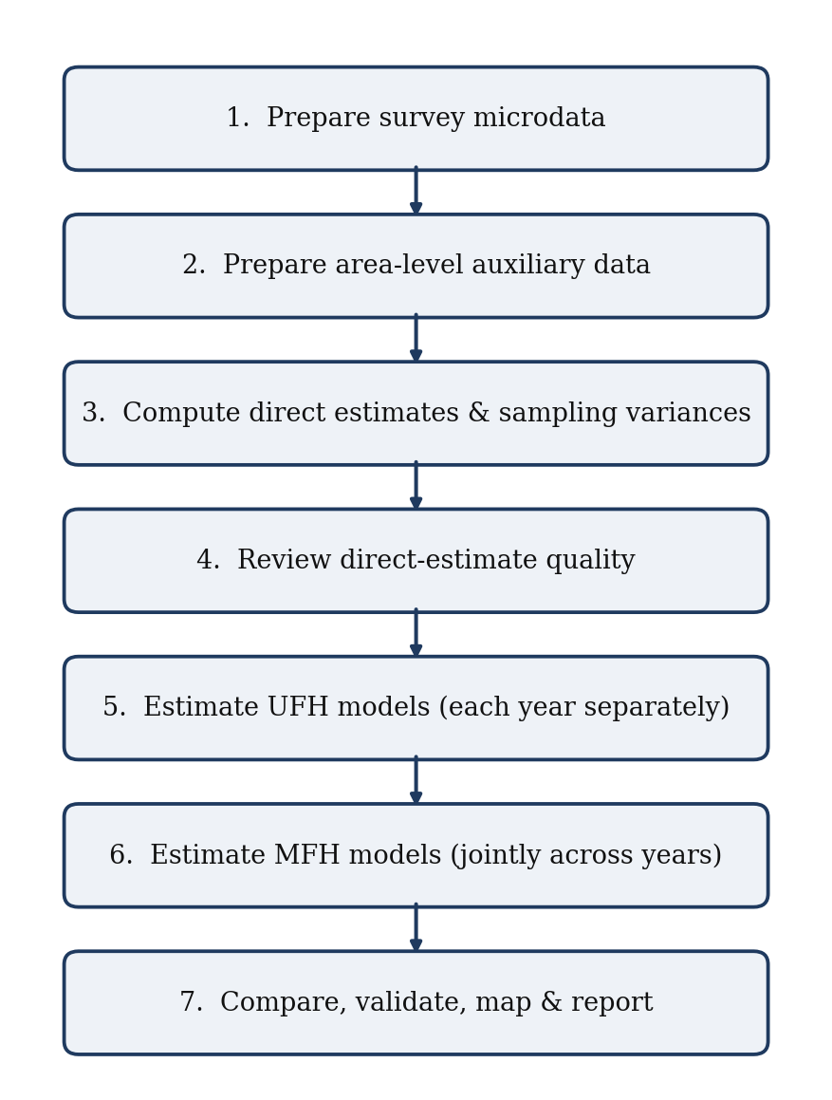
Figure 1. The seven-step poverty-mapping workflow.
Step 1. Prepare the household survey microdata.
The survey data must contain the welfare variable, poverty line, survey weights, geographic domain identifier, year, and, where available, PSU and strata identifiers. The objective of this step is to ensure that direct poverty estimates can be computed consistently for each target area and year.
Step 2. Prepare the area-level auxiliary data.
Auxiliary variables should be available for all target areas and should be conceptually related to poverty or welfare. They may come from a census, population register, administrative database, satellite data, or other reliable source. These variables provide the additional information that allows the Fay-Herriot models to improve on direct survey estimates.
Step 3. Compute direct estimates and sampling variances.
Direct estimates are survey-based poverty estimates for each area and year. They use only the sample observations from the area itself. These estimates are the starting point for the small area models. Their sampling variances are equally important because they determine how much weight the model gives to the direct survey estimate relative to the model prediction.
Step 4. Review the quality of the direct estimates.
Before fitting UFH or MFH models, users should review sample sizes, standard errors, coefficients of variation, missing estimates, zero or missing variances, and outlier values. This step is essential because the Fay-Herriot models do not replace the survey evidence; they build on it. Weak or inconsistent direct estimates should be understood before model-based estimates are produced.
Step 5. Estimate UFH models.
UFH models are estimated separately for each year. They combine direct estimates with area-level covariates to improve precision, especially in areas with small sample sizes or high sampling variability. UFH provides the cross-sectional model-based estimate for each year and serves as an important benchmark even when MFH is ultimately preferred.
Step 6. Estimate MFH models.
MFH models estimate multiple years jointly. They borrow strength not only across areas but also across time by allowing poverty estimates for the same area to be correlated across years. This can improve the stability and comparability of estimates over time, especially when the objective is to assess changes between two or more survey rounds.
Step 7. Compare, validate, map, and report results.
The final stage is not simply to select one set of estimates. Users should compare direct, UFH, and MFH estimates; review uncertainty measures and diagnostics; examine maps and changes over time; conduct sensitivity checks; and prepare documentation. The final report should clearly explain the data sources, model choices, diagnostics, limitations, and recommended estimates.

2.2 Role of direct estimates in the workflow
Direct estimates should always be produced and reviewed, even when they are too imprecise for final reporting at the small-area level. They provide the empirical anchor for the UFH and MFH models.
Direct estimates answer the question: what does the survey alone imply for each area and year?
UFH estimates answer the question: what does the survey imply after borrowing strength across areas within a year? MFH estimates answer the question: what does the survey imply after borrowing strength across areas and across time?
This distinction is important for interpretation. Model-based estimates should not be treated as independent of the survey. They are improved estimates that combine survey information with auxiliary data under explicit modeling assumptions. For this reason, large differences between direct, UFH, and MFH estimates should be investigated rather than ignored.

2.3 When to use UFH
UFH should be used when the objective is to produce small-area poverty estimates for one year or when each year is to be modeled separately. It is also the recommended first model to run before fitting MFH, because it provides a cross-sectional benchmark for each year.
UFH is appropriate when only one survey year is available; the main objective is a poverty map for a single point in time; time comparability is not the central objective; the user wants a baseline model before estimating MFH; the number of years is too small for MFH to be useful; MFH models do not converge or fail key diagnostics; or direct estimates are available by area, but some have high standard errors or high coefficients of variation.
UFH should normally be reported even when MFH is used. It helps users understand how much the final estimates depend on the time-correlation structure introduced by MFH.

2.4 When to use MFH
MFH should be used when estimates are needed for multiple years and comparability over time is important. Separate UFH models may produce reasonable estimates within each year, but they can generate unstable year-to-year patterns if direct estimates are noisy, covariates differ across years, or sampling variation is large in some areas.
MFH is appropriate when poverty maps are needed for two or more time points; analysts want to assess changes in poverty over time; direct estimates are unstable in some areas or years; there is reason to expect area-level poverty to be correlated over time; the number of areas is sufficient to estimate the model reliably; the same or comparable area definitions are available across years; or the welfare aggregate, poverty line, and auxiliary variables are sufficiently comparable across years.
MFH is often preferred for trend analysis because it reduces unstable year-to-year movements that arise from sampling variation. However, MFH should not be accepted mechanically. It should be used only when diagnostics are satisfactory and when the resulting trends are plausible in light of the direct estimates, auxiliary data, and country context.

2.5 How UFH and MFH should be reported together
The recommended reporting approach is to present direct, UFH, and MFH estimates together.
Direct estimates show the survey-only evidence. UFH estimates show the cross-sectional model-based results. MFH estimates show the time-consistent model-based results. Presenting the three estimates together improves transparency and helps users understand the model’s contribution.
When the objective is a single-year poverty map, UFH may be the preferred model-based estimate. When the objective is to compare poverty across years, MFH may be the preferred estimate, provided that model diagnostics are satisfactory. In both cases, direct estimates should remain visible in the analysis because they are the basis for validating the model results.
A practical reporting table should therefore include, for each area and year direct estimate; direct standard error and coefficient of variation; UFH estimate and uncertainty measure; MFH estimate and uncertainty measure, when applicable; difference between UFH and MFH estimates; and flags for areas with high uncertainty, large model adjustments, or diagnostic concerns.

2.6 Key decision points
Users should make several decisions before finalizing results.
First, they should decide whether the main objective is cross-sectional mapping, trend analysis, or both. This determines whether UFH alone is sufficient or whether MFH should be used as the preferred model.
Second, they should decide whether the direct estimates are reliable enough to support modeling. Areas with very small samples, missing variances, or extremely high coefficients of variation should be flagged before model estimation.
Third, they should assess whether the auxiliary variables are suitable. Covariates should be available for all target areas, conceptually related to poverty, and measured consistently across areas and years.
Fourth, they should decide whether the model estimates are credible. This requires reviewing diagnostics, comparing direct, UFH, and MFH estimates, checking sensitivity to model choices, and verifying that maps do not show implausible spatial or temporal patterns.
Fifth, they should decide which estimates are appropriate for publication. Estimates should not be published only because the model ran successfully. Publication should depend on data quality, model diagnostics, uncertainty measures, sensitivity checks, and technical review.

2.7 Recommended default workflow
For most applications, the recommended default workflow is:
- Prepare and harmonize survey, auxiliary, population, and geographic data.
- Compute direct estimates and sampling variances for each area and year.
- Review direct estimates, sample sizes, standard errors, and coefficients of variation.
- Run UFH models separately by year.
- Review UFH diagnostics and compare UFH estimates with direct estimates.
- Run MFH models when two or more comparable years are available.
- Compare direct, UFH, and MFH estimates.
- Review uncertainty, diagnostics, sensitivity checks, and maps.
- Select recommended estimates for reporting.
- Document all data sources, model choices, diagnostics, limitations, and interpretation guidance.
This workflow should be applied iteratively. If diagnostics reveal problems, users should return to earlier steps, review the input data, adjust covariates, reconsider variance options, or simplify the model before producing final maps.

3. Data Requirements
Area-level SAE draws on four data sources that must be mutually consistent: the survey microdata, the area-level auxiliary data, the geographic boundaries, and the area population sizes. Consistency of the area identifiers across all four is the single most important precondition for a successful run.

3.1 Overview of required inputs
A poverty mapping exercise using UFH and MFH requires several types of data. These inputs must be prepared before model estimation because the Fay-Herriot models depend on correctly matched area-level information.
The core required inputs are four: household survey microdata, used to compute direct poverty estimates and sampling variances; area-level auxiliary data, used as covariates in the UFH and MFH models; geographic boundary data, used to produce maps; and population-size data, used for aggregation, benchmarking, and interpretation.
Optional inputs include benchmark estimates at a higher geographic level, such as official regional or national poverty estimates, when these are considered reliable and should be preserved.
All input files must use consistent area identifiers and year definitions. The same domain code should refer to the same geographic area in the survey data, auxiliary data, population data, benchmark data, and shapefile. If area definitions differ across data sources or across years, they must be harmonized before estimation.

3.2 Required survey microdata
The survey data are used to compute direct estimates of poverty and their sampling variances for each target area and year. The data should contain one record per household or individual, depending on the welfare measure and the unit of analysis.
The minimum required variables are:
TABLE I
Required Survey Microdata Variables
Variable | Description
year | Survey year or survey round.
domain | Small-area identifier, such as province, district, NUTS3, LAU1, municipality, or another target geography.
welfare | Welfare aggregate, such as income, consumption, equivalized income, consumption per capita, or consumption per adult equivalent.
povline | Poverty line, if the poverty line varies by observation, area, household type, or year.
weight | Survey sampling weight.
psu | Primary sampling unit identifier, if available.
strata | Survey stratum identifier, if available.
household_id | Household identifier, optional but recommended.
The app allows users to map the names of these variables. Therefore, the variables do not need to have exactly the names shown above, but users must correctly identify them in the app.
Survey design variables should be retained whenever available. PSU and strata identifiers are important for estimating sampling variances. They may also be needed when estimating covariance across years, especially if there is sample overlap or repeated survey structure.
Before computing direct estimates, users should confirm that the welfare aggregate, poverty line, weights, and geographic identifiers are final and consistent with the official poverty measurement framework.

3.3 Survey data quality requirements
The survey microdata should be reviewed before being used in the app. At a minimum, users should check whether the welfare variable has missing, zero, negative, or implausibly large values; whether the poverty line is correctly defined and expressed in the same welfare units; whether survey weights are present, positive, and plausible; whether PSU and strata identifiers are available and correctly coded; whether each observation is assigned to a valid domain; whether the survey year or round is correctly coded; whether the same household or individual appears more than once unless the survey design requires it; and whether area codes contain formatting problems, such as leading zeros, capitalization differences, or hidden spaces.
For repeated cross-sections, users should also verify that the welfare aggregate, poverty line, survey weights, and domain definitions are comparable across years. If comparability problems exist, they should be documented and resolved before MFH is used for trend analysis.

3.4 Required auxiliary data
Auxiliary data are area-level variables used as predictors in the UFH and MFH models. These variables should be available for all target areas, including areas with small or zero survey sample sizes.
Auxiliary variables may come from population censuses; population registers; administrative records; tax or social registry data, where appropriate and available; labor market or education administrative systems; geospatial indicators, such as nighttime lights or accessibility measures; and other reliable area-level data sources.
Examples of useful auxiliary variables include population age structure; education levels; employment and unemployment indicators; household size indicators; housing quality indicators; urbanization indicators; asset ownership rates; administrative income or benefit indicators; census- or register-based welfare proxies; and nighttime lights or other geospatial indicators, where appropriate.
The auxiliary data should include:
TABLE II
Required Auxiliary Data Variables
Variable | Description
domain | Area identifier matching the survey, population data, and shapefile.
year | Year, if covariates vary over time.
Covariates | Area-level predictors used in the UFH and MFH models.
If covariates are fixed over time, such as variables from a census, they can be used for all years, provided this is conceptually appropriate. If time-varying covariates are available, they should be aligned as closely as possible with the survey years.

3.5 Auxiliary data quality requirements
Auxiliary variables should be selected because they are conceptually related to poverty and available for all areas, not only because they improve the fit in the sample.
Before modeling, users should check whether each target area has a complete set of auxiliary variables; whether covariates are measured consistently across areas; whether time-varying covariates correspond to the correct years; whether variables have missing values, outliers, or implausible values; whether variables are constant or nearly constant across areas; whether highly correlated variables may create multicollinearity; and whether any covariate is mechanically derived from the direct poverty estimate itself.
Auxiliary variables should not be constructed from the same survey direct estimates that the model is trying to improve. Doing so can create circularity and overstate model performance.
When using administrative or register-based data, users should check whether coverage differs across areas. For example, indicators based on program participation may reflect both poverty and program coverage, which should be considered when interpreting model results.

3.6 Required geographic data
To produce maps, the user needs a geographic boundary file for the target areas. In the app, this is expected as an RDS file containing an sf object.
The geographic file should include:
TABLE III
Required Geographic Data Fields
Variable | Description
domain | Area identifier matching the survey, auxiliary data, and population data.
Geometry | Polygon geometry for each target area.
Area name | Optional human-readable area label.
The domain codes in the shapefile must match those in the survey and auxiliary data. Each target area should appear exactly once in the geographic file.
Before mapping, users should check whether every model estimate joins to one polygon, whether every polygon has a matching estimate, whether there are duplicate domain codes, whether boundaries correspond to the same reference year as the statistical data, whether the coordinate reference system is appropriate for mapping, and whether any boundary changes occurred between survey years.
If boundaries changed over time, users should harmonize all data to a common geography before estimating changes or producing comparable maps.

3.7 Population-size data
Population-size data are needed for aggregation, benchmarking, and interpretation. They are also useful for producing weighted summaries across areas and for understanding the policy relevance of area-level estimates.
The population file may be in long or wide format.
Long format:
TABLE IV
Population-Size Data, Long Format
domain | year | population
A001 | 2012 | 125000
A001 | 2013 | 126500
Wide format:
TABLE V
Population-Size Data, Wide Format
domain | pop_2012 | pop_2013
A001 | 125000 | 126500
Population sizes should correspond to the same population universe as the survey estimates. For example, if poverty is estimated for individuals, population counts should refer to individuals. If estimates are household-level, the population file should be consistent with that unit of analysis or clearly documented.
Users should check that population values are positive and plausible, population totals by year are consistent with official statistics, the population file includes all target areas, population definitions are consistent across years, and the population universe matches the survey and poverty indicator.

3.8 Optional benchmark data
Benchmark data may be used to align small-area estimates with trusted estimates at a higher geographic level, such as regions or national totals. Benchmarking is useful when official regional or national estimates are considered reliable and should be preserved in the final results.
Benchmark data should include:
TABLE VI
Optional Benchmark Data
Variable | Description
Benchmark area | Higher-level geographic unit, such as a region or the national total.
Year | Survey year or reference year.
Benchmark estimate | Direct, official, or otherwise trusted estimate.
Population | Population size, if needed for aggregation.
Benchmarking should be used only when the benchmark estimate is credible and corresponds to the same welfare variable, poverty line, population universe, and reference year as the small-area estimates. If the benchmark and small-area inputs are not conceptually aligned, benchmarking may create inconsistencies rather than improve the results.

3.9 Minimum data-readiness checklist
Before running UFH or MFH models, users should confirm that:
- Survey data contain the required welfare, poverty line, weight, domain, and year variables.
- PSU and strata variables are available, or their absence is documented.
- Direct estimates can be computed for the target areas and years.
- Sampling variances can be computed, or a clear variance-smoothing strategy is available.
- Auxiliary variables are available for all target areas.
- Domain identifiers match across survey, auxiliary, population, and geographic data.
- Population-size data are available and consistent with the survey universe.
- Geographic boundaries match the target domains.
- Repeated cross-sections use comparable welfare variables, poverty lines, weights, and area definitions.
- Optional benchmark data, if used, are consistent with the small-area estimates.
Users should not proceed to model estimation until major inconsistencies in identifiers, years, welfare definitions, poverty lines, or population universes have been resolved. These issues are usually easier to correct before model estimation than after results have been produced.

4. Preparing the Survey Data

4.1 Purpose of survey data preparation
Survey data preparation is the first substantive step in the poverty mapping workflow. The objective is to produce reliable direct estimates and sampling variances for each target area and year. These direct estimates are the dependent variable in the UFH and MFH models, so errors during survey preparation will carry over into all model-based results.
Before running the app, users should confirm that the survey data are clean, consistently coded, and aligned with the poverty measurement framework used for official or analytical reporting. Particular attention should be given to the welfare aggregate, poverty line, survey weights, area identifiers, year identifiers, and survey design variables.

4.2 Harmonizing area identifiers
Area identifiers must be consistent across all data sources. The same code should refer to the same geographic area in the survey data, auxiliary data, population data, benchmark data, and shapefile.
Before running the model, users should check that every survey domain appears in the auxiliary data; every survey domain appears in the population data, when population data are used; every target domain appears in the shapefile; every target domain has a unique code; no domain codes differ only because of formatting differences; and domain codes are stable across survey years, or have been harmonized to a common geography.
Common problems include leading zeros, capitalization differences, spaces, punctuation, or changes in administrative boundaries. For example, the codes 001, 1, and A001 may refer to the same area but will be treated as different unless harmonized.
If boundaries changed between survey years, users should not compare estimates over time until all data have been converted to a consistent geographic definition. This may require aggregating areas, splitting areas using population shares, or adopting a common reference geography.

4.3 Defining the welfare variable
The welfare variable should be the final welfare aggregate used for poverty measurement. For income-based poverty maps, this may be equivalized disposable income. For consumption-based poverty maps, it may be household consumption per capita, household consumption per adult equivalent, or another welfare aggregate consistent with the country’s poverty methodology.
Before estimation, users should check missing welfare values, zero or negative welfare values, extreme outliers, consistency of currency units, consistency of nominal or real values across years, whether welfare has already been adjusted for household size or equivalence scales, whether spatial or temporal price adjustments have already been applied, and whether the welfare aggregate corresponds to the poverty line that will be used.
For poverty indicators, the welfare variable is used to determine whether each household or individual is poor. For mean welfare indicators, the welfare variable itself is modeled after any required transformation. Users should therefore confirm whether the analysis is estimating poverty rates, mean welfare, or both.

4.4 Defining the poverty line
The poverty line must be defined before computing poverty indicators. It should be expressed in the same units and price base as the welfare variable.
The app allows two main poverty-line options.
First, the poverty line can come from a column in the survey data. This option should be used when the poverty line varies by year, region, household type, household size, equivalence scale, or other characteristics.
Second, the poverty line can be entered as a fixed numeric value. This option is appropriate when one common poverty line applies to all observations in the selected analysis.
Before computing poverty indicators, users should check whether the poverty line is missing for any observation, whether the poverty line is expressed in the same currency and time period as welfare, whether the poverty line is nominal or real, whether the poverty line varies by year or area, whether spatial price adjustments are already incorporated, and whether the line corresponds to the intended welfare aggregate and population universe.
A common source of error is applying a poverty line in one price base to a welfare aggregate in another price base. This should be checked carefully, especially in multi-year analyses.

4.5 Constructing FGT poverty indicators
The Foster-Greer-Thorbecke family of poverty measures summarizes poverty using the welfare variable and poverty line. For household or individual (i), welfare is denoted by $y_{i}$, and the poverty line is denoted by $z_{i}$ if the line varies across observations or (z) if it is common to all observations.
For a target area (d), the general FGT indicator can be written as:
FGTα,d=i∈d​wizi-yiziαI(yi<zi)i∈d​wi
where $w_{i}$ is the survey weight, (I$y_{i}<z_{i}$) identifies poor households or individuals, and $α$ determines the poverty measure.
Operationally, FGT(0) is the poverty headcount ratio, the weighted share of the population below the poverty line; FGT(1) is the poverty gap, the average proportional shortfall from the line, counting the non-poor as having zero shortfall; and FGT(2) is poverty severity, which gives greater weight to households or individuals further below the line.
For most poverty mapping applications, FGT(0) is the primary indicator. FGT(1) and FGT(2) may also be produced when sample sizes are sufficient and when the resulting direct estimates and sampling variances are reliable enough for modeling.

4.6 Applying survey weights
Survey weights should be used by default when computing direct estimates because they account for unequal selection probabilities, non-response adjustments, and calibration to population totals. Unweighted estimates may be useful for diagnostics, but they should not normally replace weighted estimates.
Recommended checks include comparing weighted and unweighted poverty estimates by area; checking whether weights are missing, zero, negative, or extreme; reviewing whether weights sum to reasonable population totals; confirming whether weights are household weights, individual weights, or another type of weight; confirming that the weight is appropriate for the unit of analysis; and checking whether weights are year-specific in repeated cross-sections.
Large differences between weighted and unweighted estimates should be investigated. They may reflect a correct survey design feature, but they may also reveal coding problems, outlier weights, or incorrect use of household and individual weights.

4.7 Preparing survey design variables
Sampling variances are required inputs for UFH and MFH. These variances should reflect the survey design as much as possible. Users should therefore retain survey design variables, including PSU and stratum identifiers, whenever available.
Before computing sampling variances, users should check whether PSU identifiers are available and uniquely coded, whether strata identifiers are available and correctly matched to PSUs, whether PSU and strata codes are unique within year or need to be combined with year identifiers, whether single-PSU strata require special treatment, whether replicate weights are available and should be used, and whether the survey design changed across years.
If PSU or strata variables are unavailable, users should document how sampling variances were estimated and discuss the implications for uncertainty. The absence of design variables does not necessarily prevent SAE, but it may weaken the reliability of the variance estimates.

4.8 Handling small or zero samples
Small area estimation is designed to improve estimates for areas with limited survey sample sizes, but the quality of the model still depends on the information available in the direct estimates and auxiliary data.
Users should flag areas with very small sample sizes, areas with zero sample observations, areas with missing direct estimates, areas with zero or missing sampling variances, areas with extremely high coefficients of variation, areas with direct estimates equal to exactly zero or one, and areas with direct estimates that appear inconsistent with neighboring areas or with auxiliary indicators.
Areas with zero sample observations require special attention. A purely synthetic estimate may be possible if auxiliary data are available, but the estimate cannot be directly validated against survey observations from that area. Such areas should be flagged in the outputs and interpreted with caution.
Areas with very small sample sizes may still contribute useful information, but their sampling variances should be carefully reviewed. If variance estimates are unstable, variance smoothing may be needed before the FH model is fitted.

4.9 Preparing repeated cross-sections for MFH
MFH requires data that are comparable across years. Users should not use MFH for trend analysis unless the survey data, welfare aggregate, poverty line, weights, and domain definitions are sufficiently consistent over time.
For repeated cross-sections, users should check that domain definitions are stable across years; welfare variables are constructed using comparable methods; poverty lines are consistently defined; price adjustments are applied consistently; survey weights are year-specific and correctly used; PSU and strata identifiers are correctly coded within each year; auxiliary variables correspond to the appropriate years; population data correspond to the same geographic and population universe; changes in survey design are documented; and domains are not split, merged, or redefined without adjustment.
If domain boundaries changed over time, users should harmonize all years to a common geography before estimating MFH models or comparing changes in poverty. If welfare measurement changed substantially, trend estimates should be interpreted cautiously and may require additional adjustment or documentation.

4.10 Preparing the analysis dataset for the app
After cleaning the survey data, users should prepare an analysis file containing the variables required by the app. The file should include one record per household or individual and should retain the variables needed to compute direct estimates and sampling variances.
At minimum, the file should include year or survey round; domain identifier; welfare variable; poverty line variable, unless a fixed poverty line will be entered in the app; survey weight; PSU identifier, if available; strata identifier, if available; and household or individual identifier, if available.
Users should save the cleaned survey dataset in the required format and keep a log of all changes made during preparation. The documentation should record how welfare was defined, how the poverty line was applied, how area codes were harmonized, how weights were used, and how missing or problematic observations were handled.

4.11 Survey data preparation checklist
Before proceeding to direct estimation, users should confirm that:
- Area identifiers are harmonized across all input files.
- The welfare variable is final, clean, and expressed in the correct units.
- The poverty line is correctly defined and aligned with the welfare variable.
- Survey weights are valid and appropriate for the unit of analysis.
- PSU and strata variables are available or their absence is documented.
- Missing or implausible welfare values have been reviewed.
- Small-sample and zero-sample areas have been flagged.
- Repeated cross-sections are comparable across years.
- Any boundary changes have been addressed.
- The cleaned survey dataset is saved and documented.
Users should not proceed to model estimation until these checks have been completed. Most problems discovered during UFH or MFH estimation are easier to resolve at the survey preparation stage than after model outputs have been produced.

5. Preparing Auxiliary Data

5.1 Purpose of auxiliary data
Auxiliary data provide the area-level predictors used in UFH and MFH models. These variables allow the model to borrow strength across areas by relating direct poverty estimates to characteristics observed for all target areas.
Good auxiliary data are essential for reliable poverty maps. If auxiliary variables are weak, inconsistent, missing for some areas, or not comparable over time, model-based estimates may be unstable or misleading. Auxiliary data should therefore be prepared and reviewed as carefully as the survey data.
In an area-level Fay-Herriot model, auxiliary variables must be available at the same geographic level as the target estimates. For example, if poverty estimates are required at the district level, the auxiliary variables should also be available for every district. Variables measured at higher levels may be used only if they are meaningful at the target level and do not create artificial similarity across areas.

5.2 Selecting candidate covariates
Candidate covariates should be selected because they are conceptually related to poverty or welfare and are available for all target areas. They should not be selected only because they fit the sample well.
Useful covariates often describe structural characteristics of areas, such as demographic composition, education, labor market conditions, housing quality, urbanization, asset ownership, administrative income proxies, or geospatial indicators. The exact choice should reflect the country context, poverty concept, and available data.
Good covariates should be measured consistently across areas, available for all target areas, conceptually related to poverty or welfare, measured independently of the direct poverty estimates, stable enough to support prediction, interpretable for technical review and policy communication, and comparable across years when used in MFH.
Users should avoid including covariates only because they improve the in-sample fit. A model with many weak or opportunistically selected variables may appear to perform well but can produce unreliable estimates, especially when the number of target areas is limited.

5.3 Avoiding circularity
Auxiliary variables should not be mechanically derived from the same survey direct estimates that the UFH or MFH model is trying to improve. For example, a variable constructed from the area-level survey poverty rate should not be used as a predictor of that same poverty rate.
Circularity can make the model appear stronger than it is and may understate uncertainty. It can also obscure whether the model is genuinely borrowing strength from external information or simply reusing the direct estimate.
This does not mean that survey-based area characteristics can never be used. However, if a covariate is constructed from the same survey used to compute the direct estimate, users should carefully consider whether it creates endogeneity, circularity, or excessive dependence on noisy area-level survey data. In most poverty mapping applications, auxiliary variables from censuses, registers, administrative systems, or geospatial sources are preferable.

5.4 Aligning covariates over time
For UFH, each year can be modeled separately, so covariates may be year-specific. For MFH, covariates must be organized consistently across years because the model estimates multiple years jointly.
Users should distinguish among the three types of covariates.
First, time-invariant covariates are fixed across years, such as baseline census characteristics or geographic indicators. These variables can be used for multiple years when they represent structural area characteristics that are not expected to change quickly.
Second, time-varying covariates change by year, such as unemployment rates, administrative income indicators, school enrollment rates, population structure, or nighttime lights. These variables should be aligned with the relevant survey years as closely as possible.
Third, lagged covariates may be used when current-year covariates are unavailable. For example, administrative indicators from year (t-1) may be used to predict poverty in year (t). When lagged variables are used, the timing should be documented and justified.
For MFH, users should check whether differences across years reflect real changes or changes in definitions, coverage, data collection systems, or administrative reporting. Apparent changes in covariates can create misleading poverty trends if they are caused by measurement changes rather than real area-level changes.

5.5 Harmonizing area identifiers and years
Auxiliary data must be correctly matched to the survey's direct estimates. The area identifier in the auxiliary file should correspond exactly to the domain identifier used in the survey data, population data, and shapefile.
Before modeling, users should check whether all target areas appear in the auxiliary data; whether each target area appears only once per year; whether domain codes use consistent formatting; whether leading zeros, spaces, capitalization, or punctuation create mismatches; whether auxiliary variables correspond to the correct survey years; whether areas that changed boundaries over time have been harmonized; and whether national or regional totals implied by the auxiliary data are plausible.
If the auxiliary data are available at a different geographic level from the target estimates, they should be converted to the target geography before modeling. The conversion method should be documented, especially if population weights, area shares, or administrative crosswalks are used.

5.6 Transforming covariates
Covariates may need to be transformed before modeling. Transformations can improve interpretability, reduce the influence of outliers, and stabilize relationships with poverty.
Common transformations include converting counts into shares or rates, taking logs of highly skewed positive variables, standardizing variables measured in different units, grouping categories into interpretable indicators, constructing interactions when there is a clear conceptual reason, and winsorizing or otherwise treating extreme outliers when justified.
All transformations should be documented. Users should record the original variable, the transformation applied, and the reason for applying it.
Transformations should not be used mechanically. For example, a log transformation is appropriate only for positive variables and should be avoided or modified when variables contain zeros or negative values. Similarly, interactions should be used sparingly because they can increase the risk of overfitting.

5.7 Checking missing values and coverage
Auxiliary variables should be available for all target areas. Missing values are especially problematic because areas with missing covariates cannot be predicted reliably.
Before modeling, users should check whether any target area has missing covariates; whether missingness is concentrated in specific regions or types of areas; whether missing values reflect true zero values, unavailable data, or coding errors; whether imputation is needed and defensible; and whether the same missing-value treatment is applied consistently across years.
If missing values are limited and clearly due to coding errors, they should be corrected using the source data. If values are genuinely unavailable, users may consider imputation, but this should be done cautiously and documented. Variables with many missing values should generally be excluded from the candidate covariate set.

5.8 Checking outliers and implausible values
Outliers in auxiliary variables can strongly influence Fay-Herriot models, especially when the number of areas is small. Users should review distributions of all candidate covariates before estimation.
Recommended checks include minimum and maximum values, histograms or density plots, boxplots by year or region, maps of key covariates, correlations with direct poverty estimates, and comparison with known country patterns.
Outliers should not be removed automatically. Some outliers may represent genuinely unusual areas, such as capital cities, remote regions, or sparsely populated areas. Others may reflect coding errors, inconsistent definitions, or unit problems. Users should investigate outliers and decide whether to correct, transform, winsorize, retain, or exclude the variable.

5.9 Checking collinearity and redundancy
Many area-level covariates are highly correlated. For example, education, housing quality, employment structure, and urbanization may all capture similar dimensions of development. Including many highly correlated variables can make model estimates unstable and difficult to interpret.
Before model selection, users should review pairwise correlations among covariates, variables that are nearly identical by construction, variables that are linear combinations of other variables, variables that differ only in scale or denominator, and groups of indicators that capture the same concept.
When several variables measure similar concepts, users should retain the one that is most reliable, interpretable, and consistently measured across areas and years. Alternatively, users may construct a small number of summary indicators, provided the construction is transparent and documented.

5.10 Avoiding overfitting
Overfitting is a major risk in area-level models because the number of areas may be limited. A model with too many covariates may fit the direct estimates well but perform poorly for prediction and may produce unstable estimates for areas with noisy or missing direct estimates.
Recommended practice is to start with a small, conceptually justified set of covariates; avoid including many variables relative to the number of areas; use BIC when parsimony is important; use AIC as a sensitivity check when predictive performance is prioritized and the number of areas is adequate; avoid highly collinear variables; review whether selected covariates have plausible signs and magnitudes; check whether selected covariates are stable across years; and compare results across reasonable alternative covariate sets.
Automatic model selection should support, not replace, substantive judgment. The final model should be statistically defensible, interpretable, and credible to country experts.

5.11 Preparing the auxiliary dataset for the app
The auxiliary dataset should contain one row per target area and year when covariates vary over time. If covariates are time-invariant, the dataset may contain one row per area, or the same values may be repeated for each year, depending on the app workflow.
At minimum, the auxiliary dataset should include the domain identifier, the year (where covariates vary over time), the candidate covariates, and, optionally, area names or labels for review.
The dataset should not include variables that are identifiers, labels, or administrative metadata as candidate covariates unless they have been intentionally constructed as meaningful predictors.
Before uploading the file to the app, users should confirm that numeric covariates are stored as numeric variables, not as text; categorical variables have been converted into usable indicators if needed; and variable names are clear enough to be reviewed in model outputs.

5.12 Auxiliary data preparation checklist
Before proceeding to model estimation, users should confirm that:
- Auxiliary variables are available for all target areas.
- Domain codes match the survey, population, and shapefile domain codes.
- Year definitions are correct and aligned with survey years.
- Covariates are conceptually related to poverty or welfare.
- Covariates are not mechanically derived from the direct poverty estimates.
- Missing values have been reviewed and addressed.
- Outliers and implausible values have been investigated.
- Highly collinear or redundant variables have been reviewed.
- Transformations have been documented.
- The candidate covariate set is not too large relative to the number of areas.
- Time-varying covariates are comparable across years.
- The final auxiliary dataset is saved and documented.
Users should not proceed to UFH or MFH estimation until the auxiliary data have passed these checks. Poor auxiliary data can produce precise-looking but unreliable poverty maps.

6. Direct Estimates and Sampling Variances

6.1 Role of direct estimates
Direct estimates are the survey-based estimates of poverty for each area and year. They use only observations sampled within the area itself, along with survey weights and survey design information. They are called “direct” because they do not rely on a model linking poverty to auxiliary variables.
In the Fay-Herriot framework, direct estimates are the dependent variable. UFH and MFH models improve precision by combining these direct estimates with area-level auxiliary information. Direct estimates, therefore, provide the empirical anchor for the model-based estimates.
Direct estimates answer the question: what does the survey alone imply for each area and year? Model-based estimates answer a different question: what is the best estimate after combining the survey evidence with auxiliary data, under the model's assumptions?
This distinction is important. Direct estimates should always be produced and reviewed, even if they are too imprecise to publish for all areas. If the direct estimates contain errors, inconsistencies, or implausible values, the UFH and MFH estimates are likely to be affected as well.

6.2 Computing direct estimates
For each area (d) and year (t), let ${\hat{θ}}_{dt}^{DIR}$ denote the direct estimate of the poverty indicator, and let $θ_{dt}$ denote the true but unknown area poverty indicator.
For a poverty headcount ratio, the direct estimate is the weighted share of households or individuals whose welfare is below the poverty line:
θdtDIR=i∈d,t​wi I(yi<zi)i∈d,t​wi
where $w_{i}$ is the survey weight, $y_{i}$ is the welfare aggregate, $z_{i}$ is the poverty line, and $I(y_{i}<z_{i})$ is an indicator equal to one when observation (i) is poor.
If the poverty line is common to all observations, $z_{i}$ can be replaced by (z). If the poverty line varies by year, area, household type, or another characteristic, the observation-specific poverty line $z_{i}$ should be used.
Operationally, users should produce a direct-estimate table with the following variables:
TABLE VII
Variables in the Direct-Estimate Table
Variable | Description
domain | Small-area identifier.
year | Survey year or round.
sample_size | Number of sampled observations in the area-year cell.
direct_estimate | Direct poverty estimate.
sampling_variance | Estimated sampling variance of the direct estimate.
standard_error | Square root of the sampling variance.
cv | Coefficient of variation, usually standard error divided by the direct estimate.
Direct estimates should be computed using the appropriate survey weights and, where possible, the survey design variables.

6.3 Computing sampling variances
The sampling variance measures the uncertainty of the direct estimate caused by the survey design and sample size. It is a required input for UFH and MFH models.
The Fay-Herriot measurement equation can be written as:
$${\hat{θ}}_{dt}^{DIR}=θ_{dt}+e_{dt}$$
where ${\hat{θ}}_{dt}^{DIR}$ is the direct estimate, $θ_{dt}$ is the true area poverty indicator, and $e_{dt}$ is the sampling error. The sampling variance is:
$$Var(e_{dt})=ψ_{dt}.$$
The value of $ψ_{dt}$ determines how much weight the model gives to the direct estimate. Areas with small sampling variances are treated as having more precise survey information and receive less shrinkage toward the model prediction. Areas with large sampling variances are treated as less precise and receive more shrinkage toward the prediction from auxiliary variables.
Sampling variances should be estimated using the survey design whenever possible. This may require PSU identifiers, strata identifiers, replicate weights, or other design information. If design variables are unavailable, users should document the variance estimation approach and its limitations.

6.4 Standard errors and coefficients of variation
The standard error is the square root of the sampling variance:
$$SE({\hat{θ}}_{dt}^{DIR})=\sqrt{ψ_{dt}}.$$
The coefficient of variation is commonly computed as:
$$CV({\hat{θ}}_{dt}^{DIR})=\frac{SE({\hat{θ}}_{dt}^{DIR})}{{\hat{θ}}_{dt}^{DIR}}.$$
The CV is useful because it expresses uncertainty relative to the size of the estimate. High CVs indicate that the direct estimate is imprecise and that model-based estimates may add value.
Users should interpret CVs carefully when the direct estimate is close to zero. In such cases, the CV can be extremely large or unstable even when the standard error is not unusually high. For this reason, standard errors, confidence intervals, sample sizes, and direct estimates should be reviewed together.

6.5 Handling zero, one, and missing direct estimates
Direct estimates equal to exactly zero or one can occur when all sampled observations in an area are classified as non-poor or poor. These values may be correct, especially in very small samples, but they can create difficulties for transformations and variance estimation.
Users should flag areas with direct estimates equal to zero, areas with direct estimates equal to one, areas with missing direct estimates, areas with zero or missing sampling variances, areas with very small sample sizes, and areas with unusually high or low direct estimates relative to neighboring areas or similar areas.
A zero or one direct estimate should not automatically be changed. The first step is to check whether it reflects the underlying survey data or a data-processing error. If the value reflects a very small sample, the estimate should be retained but flagged, and its sampling variance should be carefully reviewed.
Areas with no sampled observations do not have direct estimates. Model-based predictions may still be produced if auxiliary data are available, but these estimates are synthetic and should be clearly flagged because they are not anchored in area-specific survey observations.

6.6 Smoothing sampling variances
Direct variance estimates can be unstable when area sample sizes are small. Some areas may have variance estimates that are zero, missing, or implausibly large or small. If these unstable variance estimates are used directly, they can distort the UFH or MFH model.
Variance smoothing uses a regression-based or related approach to stabilize the sampling variances before they are used in the model. The purpose is not to hide uncertainty. The purpose is to prevent unreliable variance estimates from misleading the model about which direct estimates are precise and which are noisy.
Recommended practice is to use direct variances when they are stable and credible; replace only outlier, zero, or missing variances when most direct variance estimates are reliable; smooth all variances when direct variance estimates are highly unstable across many areas; compare results under alternative variance options as a sensitivity check; and document the variance treatment used in the final model.
In the app, the main variance options are:
TABLE VIII
Sampling-Variance Options
Option | Interpretation
direct | Use the raw survey variance estimates.
sm_out | Smooth only outlier, zero, or missing variances.
sm_all | Replace all variances with smoothed variances.
A practical default is to start with sm_out, then compare results with direct and sm_all where feasible.

6.7 Sampling covariance over time
When comparing estimates over time, the covariance of sampling errors across years may matter. This is especially relevant when surveys have overlapping samples, repeated PSUs, rotating panels, or other design features that create correlation between direct estimates in different years.
The cross-year covariance arises from the persistent cluster effect shared by households in the same PSU: it is positive when the survey reuses PSUs across rounds (rotating panels, retained clusters, or a panel component) and zero when the rounds are independent. It should be estimated over the full sample in both rounds, not only the re-interviewed households. Section 8.7 develops this point and describes the Dashboard’s covariance options.
For two years $t_{1}$ and $t_{2}$, the sampling covariance can be written as:
$$Cov(e_{dt_{1}},e_{dt_{2}}).$$
This covariance affects the standard error of estimated poverty changes. For example, the variance of the difference between two direct estimates is:
$$Var\left({\hat{θ}}_{dt_{2}}^{DIR}-{\hat{θ}}_{dt_{1}}^{DIR}\right)=Var\left({\hat{θ}}_{dt_{2}}^{DIR}\right)+Var\left({\hat{θ}}_{dt_{1}}^{DIR}\right)-2 Cov\left(e_{dt_{2}},e_{dt_{1}}\right)$$
If the covariance is ignored when it is important, uncertainty around changes over time may be overestimated or underestimated. Users should therefore review whether the survey design creates cross-year dependence and select the covariance option accordingly in the MFH and comparison stages.
If samples are independent across years, assuming zero covariance may be reasonable. If the same PSUs or households are observed across years, a covariance option that allows cross-year correlation is usually preferable.

6.8 Quality checks for direct estimates
Before fitting UFH or MFH models, users should review the direct estimates and their uncertainty. Recommended checks include sample size by area and year; direct poverty rate by area and year; sampling variance by area and year; standard error by area and year; coefficient of variation by area and year; areas with zero, one, or missing direct estimates; areas with zero, missing, or extreme sampling variances; areas with unusually high or low poverty estimates; weighted versus unweighted direct estimates; consistency of direct estimates with known country patterns; and consistency of direct estimates across years.
Direct estimates with high CVs are not necessarily wrong. They often indicate areas where model-based estimates are most useful. However, direct estimates that are implausible, incorrectly computed, or based on inconsistent inputs should be corrected before modeling.

6.9 Direct-estimate outputs for the app
The direct-estimate stage should produce a clean area-year dataset that can be used by the UFH and MFH models. The dataset should include domain identifier; year; direct estimate; sampling variance; standard error; coefficient of variation; sample size; and optional flags for small samples, missing values, zero or one estimates, and variance problems.
Users should save this dataset and review it before proceeding. It is good practice to include this table in the technical annex of the final report because it presents the survey evidence on which the small-area estimates are based.

6.10 Direct-estimate checklist
Before proceeding to UFH or MFH estimation, users should confirm that:
- Direct estimates have been computed using the correct welfare variable and poverty line.
- Survey weights have been applied correctly.
- Sampling variances have been computed using the best available survey design information.
- Standard errors and CVs have been reviewed.
- Small-sample and zero-sample areas have been flagged.
- Zero, one, and missing direct estimates have been investigated.
- Zero, missing, or outlier sampling variances have been addressed or flagged.
- The variance smoothing strategy has been selected and documented.
- Cross-year sampling covariance has been considered for repeated surveys.
- Direct estimates are plausible in light of country knowledge and auxiliary data.
Users should not proceed to final model selection until the direct estimates and sampling variances have passed these checks.

7. UFH Methodology

7.1 Purpose of the UFH model
The Univariate Fay-Herriot model is an area-level small area estimation model used to improve the precision of direct estimates for a single year. It combines two sources of information: the direct survey estimate for each area and the prediction from area-level auxiliary variables.
The direct estimate provides the survey evidence for the area. The auxiliary variables provide information about how poverty varies across areas. The UFH model combines these two sources in a statistically disciplined way, giving more weight to the direct estimate when it is precise and more weight to the model prediction when the direct estimate is noisy.
UFH is especially useful when some areas have small sample sizes, high standard errors, or high coefficients of variation. It should normally be estimated separately for each survey year and used as the main cross-sectional benchmark before MFH is fitted.

7.2 Model intuition
The UFH model produces a composite estimate. This means that the final estimate is partly based on the direct survey estimate and partly based on the regression prediction from auxiliary variables.
For areas with precise direct estimates, the UFH estimate will usually remain close to the direct estimate. For areas with noisy direct estimates, the UFH estimate will rely more heavily on the model prediction. This movement toward the model prediction is often called shrinkage.
Equivalently, the UFH (EBLUP) estimator can be understood as a weighted average of the direct estimator and the regression-synthetic part. The estimated shrinkage factor places more weight on the direct estimator when its sampling variance is small and on the regression-synthetic prediction when it is large. For an out-of-sample area – one with no survey observations – the prediction reduces to the regression-synthetic component alone, and such estimates should be clearly flagged because they are not anchored in any area-specific survey evidence.
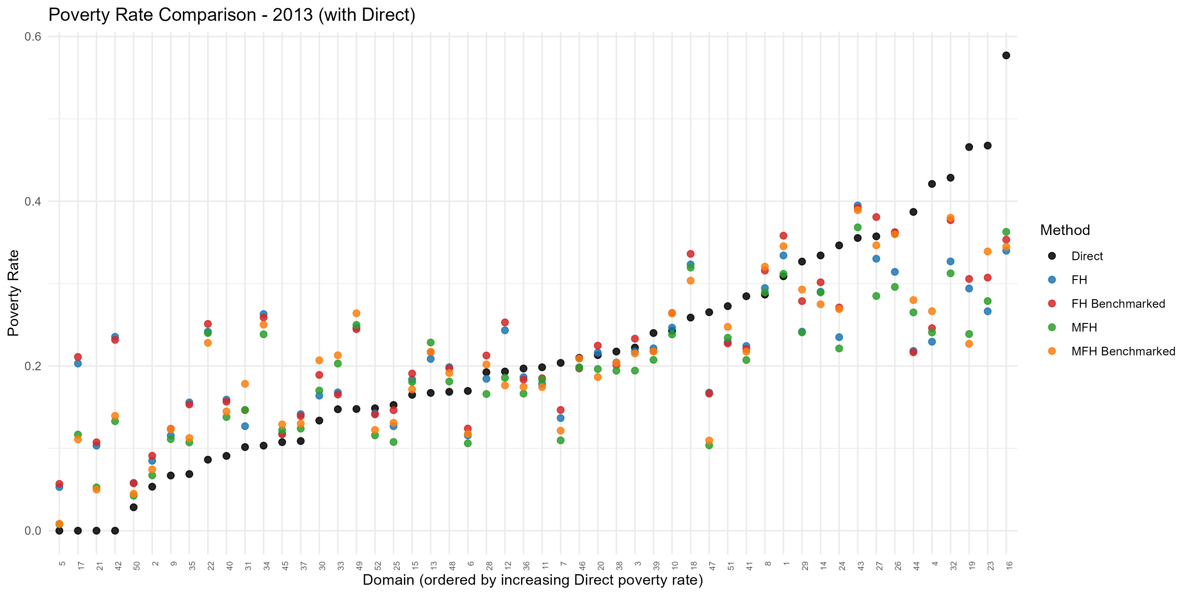
Figure 2. Domain-level poverty rate by method, 2013: direct, FH, and MFH estimates (benchmarked and unbenchmarked), with domains ordered by the direct poverty rate. The model-based estimates pull noisy direct estimates toward the regression prediction (shrinkage). Produced by the EU SAE Dashboard.
Shrinkage is not a mechanical correction toward the national mean. It is a movement toward the value predicted by the area’s characteristics. If an area has auxiliary variables associated with high poverty, the model prediction may also be high. If an area has auxiliary variables associated with low poverty, the model prediction may be low.
Operationally, the UFH model answers the question: given the direct survey estimate, its sampling variance, and the area’s auxiliary characteristics, what is the best model-based estimate of poverty for this area?

7.3 Model specification
For a fixed year, the UFH model can be written as:
$${\hat{θ}}_{d}^{DIR}=x_{d}'β+u_{d}+e_{d}$$
where ${\hat{θ}}_{d}^{DIR}$ is the direct estimate for area (d); $x_{d}$ is the vector of area-level auxiliary variables; $β$ is the vector of regression coefficients; $u_{d}$ is the area random effect; or $e_{d}$ is the sampling error of the direct estimate.
The sampling error is assumed to have mean zero and known or estimated sampling variance:
$$e_{d}∼N(0,ψ_{d})$$
where $ψ_{d}$ is the sampling variance of the direct estimate.
The area random effect captures area-level variation that is not explained by the auxiliary variables:
$$u_{d}∼N(0,σ_{u}^{2}).$$
The UFH estimate is the empirical best linear unbiased predictor of the true area indicator. In practical terms, it adjusts the regression prediction using the information contained in the direct estimate. The adjustment is larger when the direct estimate is precise and smaller when the direct estimate is noisy.
The two lines of the model have direct interpretations. The first is the sampling model: the direct estimate equals the true area value plus sampling error, whose known (or estimated) variance measures how noisy the survey estimate is. The second is the linking model: the true area value is a regression on area-level covariates plus an area random effect that captures area-level variation the covariates do not explain. The FH estimate should be consistent with the direct estimates for areas with small sampling variance or large sample sizes, while drawing more on the covariates where the direct estimate is weak.

7.4 Inputs required for UFH
The UFH model requires the following area-level inputs for each year domain identifier; direct estimate for each area; sampling variance of the direct estimate; area-level auxiliary variables; population size, if aggregation or benchmarking is needed; and geographic boundary file, if maps will be produced.
Before fitting UFH, users should confirm that the direct estimates and sampling variances have been reviewed, that auxiliary variables are available for all target areas, and that domain codes match across all input files.
Areas with missing direct estimates may still receive synthetic predictions if auxiliary variables are available, but they should be clearly flagged because the prediction is not anchored in an area-specific survey estimate.

7.5 Transformations
For poverty rates and other bounded indicators, transformations may be used to improve model performance and keep estimates within the valid range. For mean welfare, transformations may be used to reduce skewness and improve model fit.
The app supports four UFH transformation options: arcsin or no transformation for poverty indicators, and log or no transformation for mean welfare.
For poverty rates, the arcsin transformation is often useful because it helps stabilize variances and reduces the risk of producing predictions outside the valid range. For mean welfare, the log transformation may be useful when the welfare distribution is highly skewed.
As a recommended default, start with the arcsin transformation for poverty rates and, for mean welfare, the log transformation when welfare is strongly skewed; use no transformation as a sensitivity check, and review whether the transformed and untransformed models produce materially different conclusions.
Transformations should improve stability and interpretation. They should not be used to hide poor model fit or unresolved data problems.

7.6 Bias correction after back-transformation
When a model is estimated on a transformed scale, the results must be back-transformed to the original scale before interpretation. Back-transformation can introduce bias because the expected value of a nonlinear transformation is not generally equal to the inverse transformation of the expected value.
For poverty rates modeled with the arcsin transformation, bias correction is recommended when available. For mean welfare modeled with the log transformation, Duan’s smearing correction is recommended when the objective is to report estimates on the original welfare scale.
Operationally, users should remember that model diagnostics may be reviewed on the transformed scale, but final poverty rates, welfare estimates, standard errors, maps, and tables should be presented on the original scale.
Recommended practice is to use bias correction when applying nonlinear transformations, report final estimates on the original scale, document the transformation and bias-correction method, and compare transformed and untransformed results as a sensitivity check when feasible.

7.7 Covariate selection
UFH models should use a parsimonious and conceptually justified set of covariates. Because area-level models often have a limited number of observations, overfitting is a major risk.
The app can select covariates automatically using AIC or BIC. Users can also force specific covariates by entering comma-separated variable names.
As a recommended default, use BIC when the number of areas is limited or parsimony is preferred, and AIC as a sensitivity check when predictive performance is prioritized and the number of areas is adequate; force manual covariates only when there are strong substantive reasons to include specific variables. In all cases, review the selected covariates for plausibility, sign, and stability, and avoid variables that are highly collinear, redundant, or mechanically derived from the direct poverty estimates.
Automatic model selection should support, not replace, technical judgment. The final model should be explainable to statistical reviewers and country counterparts.

7.8 Variance options
The sampling variance of the direct estimate determines how much weight the UFH model gives to the direct estimate relative to the regression prediction. If sampling variances are unstable, zero, missing, or affected by very small samples, they can distort the model.
When no transformation is used, the app allows the following variance options:
TABLE IX
UFH Variance Options
Option | Interpretation
direct | Use the raw survey variance estimates.
sm_out | Smooth only outlier, zero, or missing variances.
sm_all | Replace all variances with smoothed variances.
As a recommended default, start with sm_out for the first run, compare with direct when the raw sampling variances appear reliable and with sm_all when many variance estimates are unstable, and document the variance option used in the final model.
When arcsin or log transformation is used, variance stabilization is partly handled by the transformation, and some variance options may be ignored by the app. Users should still review the direct variances and confirm that extreme or missing values have been addressed before model estimation.

7.9 Model diagnostics
UFH estimates should not be accepted simply because the model converged. Users should review diagnostics to assess whether the model is credible and whether the resulting estimates are suitable for reporting.
UFH diagnostics should include:
- Model convergence status.
- Selected covariates and their plausibility.
- Residual plots.
- Q-Q plots of residuals.
- Q-Q plots or histograms of random effects.
- Outlier areas.
- Estimated random-effect variance.
- Comparison of direct and UFH estimates.
- Comparison of direct and UFH standard errors or CVs.
- Sensitivity to covariate selection.
- Sensitivity to variance smoothing.
- Maps of estimates and uncertainty.
A good UFH model should improve precision without producing implausible estimates or excessive shrinkage. Areas with large differences between direct and UFH estimates should be reviewed carefully. Large differences may be reasonable when direct estimates are very noisy, but they may also indicate weak covariates, data errors, outliers, or model misspecification.
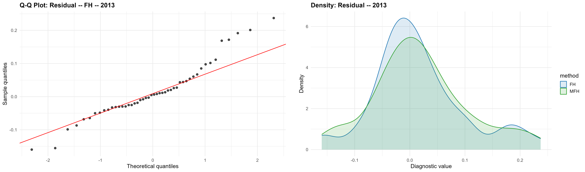
Figure 3. UFH residual diagnostics, 2013: normal Q–Q plot of the residuals (left) and the residual density for FH and MFH (right). Produced by the EU SAE Dashboard.

7.10 Interpreting UFH estimates
UFH estimates should be interpreted as model-based estimates that combine survey evidence with auxiliary data. They are usually more precise than direct estimates, but they depend on model assumptions.
Users should avoid presenting UFH estimates as if they were directly observed survey estimates. Instead, reports should explain that UFH estimates borrow strength across areas and that uncertainty measures reflect both sampling error and model uncertainty.
When interpreting results, users should consider whether UFH estimates are broadly consistent with direct estimates; whether areas with high direct-estimate uncertainty show greater model adjustment; whether estimated spatial patterns are plausible; whether uncertainty remains high in some areas; whether rankings are robust to uncertainty; or whether results are sensitive to alternative model choices.
UFH estimates are most useful when they reduce uncertainty while preserving credible spatial patterns. They should be interpreted cautiously when covariates are weak, diagnostics are poor, or estimates are highly sensitive to model choices.

7.11 Benchmarking UFH estimates
Benchmarking adjusts small-area estimates so that they aggregate to trusted estimates at a higher geographic level, such as regions or national totals. Benchmarking can be useful when official higher-level estimates are considered reliable and should be preserved.
Benchmarking can be viewed as a constrained adjustment of the model estimates so that their population-weighted aggregate reproduces the trusted higher-level total. For poverty rates the Dashboard applies a region-level (or national) ratio adjustment: a common multiplicative factor within each benchmark area, used because it keeps benchmarked rates non-negative and preserves the proportional ordering of areas. This is an implementation choice, not the only possibility – additive (raking) and other schemes are available in the benchmarking literature (Datta et al., 2011; Bell, Datta, and Ghosh, 2013). Benchmarking restores aggregate consistency but does not create new information: it is worthwhile only when the benchmark is more reliable than the small-area estimates being adjusted, and a thin region–period cell can transmit noise from the benchmark into every area it contains.
Benchmarking should be applied cautiously. It can improve consistency with official estimates, but it may also shift small-area estimates and affect area rankings. Users should compare estimates before and after benchmarking and document the benchmark source, benchmark level, and benchmarking method.
When benchmarked estimates are reported, their uncertainty should reflect the benchmarking step. Because the benchmark factor is estimated from the data and the benchmarked estimate is a nonlinear function of the fitted EBLUPs, the Dashboard estimates the benchmarked MSE by bootstrap rather than simply reusing the analytical MSE of the unbenchmarked Fay–Herriot estimator; for MFH it produces, in the same way, the cross-time error (MCPE) needed for inference on benchmarked changes (Section 8.11).
Benchmarking is most appropriate when the benchmark estimate is reliable; the benchmark uses the same welfare variable and poverty line; the benchmark refers to the same population universe; the benchmark geography is consistent with the small-area geography; or the benchmark year matches the survey year.
Benchmarking should not be used to force consistency with a benchmark that is conceptually different from the small-area estimates.

7.12 UFH outputs
The UFH stage should produce a complete set of model outputs for review, mapping, and reporting. These outputs should include area-level UFH estimates by year, standard errors or MSEs, coefficients of variation, direct versus UFH comparison tables, covariates selected for each year, model diagnostics, flags for outliers or areas with large model adjustments, maps of UFH estimates, maps of uncertainty, and output files for the MFH and comparison stages.
The UFH output table should retain the direct estimates alongside the UFH estimates. This makes it possible to assess how much the model changes the survey-only evidence and whether the changes are reasonable.

7.13 UFH checklist
Before accepting UFH results, users should confirm that:
- Direct estimates and sampling variances have been reviewed.
- Auxiliary variables are available for all target areas.
- The selected transformation is appropriate.
- Bias correction is applied when needed.
- The variance option is appropriate and documented.
- The selected covariates are plausible and not overfitted.
- The model converged successfully.
- Residuals and random effects do not show major problems.
- UFH estimates are broadly consistent with direct estimates.
- Large model adjustments have been investigated.
- UFH standard errors or CVs show reasonable precision gains.
- Results are not highly sensitive to reasonable alternative settings.
- Benchmarking, if used, is documented and reviewed.
- Final maps include uncertainty information.
UFH results should be treated as provisional until these checks have been completed.

8. MFH Methodology

8.1 Purpose of the MFH model
The Multivariate Fay-Herriot model extends the UFH framework to multiple years. While UFH estimates each year separately, MFH estimates several years jointly and allows poverty estimates for the same area to be correlated over time.
MFH is useful when the objective is not only to produce poverty maps for individual years but also to compare poverty across years. In many applications, separate UFH models may produce reasonable estimates for each year, but the resulting trends can be unstable if direct estimates are noisy, covariates differ across years, or sampling variation is large in some areas. MFH addresses this problem by borrowing strength across both areas and time.
Operationally, MFH answers the question: given the direct estimates, their sampling variances, the auxiliary variables, and the relationship between the same areas across time, what are the best model-based estimates for each area-year?

8.2 Why MFH is needed
Area-level poverty often changes gradually over time, unless there is a major economic shock, conflict, natural disaster, policy change, or survey-methodology change. The poverty level of an area in one year is therefore usually informative about its poverty level in another year.
Separate UFH models do not use this information directly. Each year is estimated independently, so the estimates for year $t_{1}$ do not help inform the estimates for year $t_{2}$. This can be a limitation when direct estimates are imprecise or when analysts need reliable estimates of change.
MFH is designed for these situations. By estimating multiple years jointly, it can reduce unstable year-to-year movements that arise from sampling variation while still allowing genuine changes in poverty to appear in the estimates.
MFH is especially useful when poverty maps are needed for two or more years; the main objective is to analyze changes over time; direct estimates are noisy in some areas or years; area-level poverty is expected to be correlated over time; the same or comparable geographic domains are available across years; welfare aggregates and poverty lines are comparable across years; or auxiliary variables are consistently measured across years.
MFH should not be used mechanically. If the survey data, poverty lines, area definitions, or auxiliary variables are not comparable across years, MFH estimates may impose artificial stability on data that are not truly comparable.

8.3 MFH model structure
For area (d) and year (t), the MFH model can be written as:
$${\hat{θ}}_{dt}^{DIR}=x_{dt}'β_{t}+u_{dt}+e_{dt}$$
where ${\hat{θ}}_{dt}^{DIR}$ is the direct estimate for area (d) in year (t); $x_{dt}$ is the vector of area-level auxiliary variables; $β_{t}$ is the vector of regression coefficients, which may vary by year; $u_{dt}$ is the area-time random effect; or $e_{dt}$ is the sampling error of the direct estimate.
The sampling error has variance:
$$Var(e_{dt})=ψ_{dt}$$
where $ψ_{dt}$ is the sampling variance of the direct estimate.
The key feature of MFH is that the random effects for the same area can be correlated across time. For example, if an area has poverty above the level predicted by its covariates in one year, the model allows that unexplained component to be related to the unexplained component in another year.
This time correlation is what allows MFH to borrow strength across years.
Two distinct covariance matrices appear in the MFH model, and they play different roles. The random-effects covariance matrix governs how each area’s unexplained component is correlated across years; it is estimated by the model, and its assumed structure is what distinguishes the MFH variants (Section 8.5). The sampling-error covariance matrix, by contrast, is not estimated by the model – it is supplied to the model as data and must be estimated from the survey beforehand (Section 8.7). Keeping the two separate avoids a common source of confusion: the model learns the first, but the analyst must provide the second.

8.4 Inputs required for MFH
MFH requires the same types of inputs as UFH, but organized consistently across multiple years. The required inputs are domain identifier; year identifier; direct estimate for each area-year; sampling variance for each area-year; area-level auxiliary variables for each area-year or time-invariant auxiliary variables repeated across years; population sizes, if aggregation or benchmarking is needed; geographic boundaries, if maps will be produced; and sampling covariance information, if cross-year sampling errors are correlated and covariance estimation is feasible.
Before fitting MFH, users should confirm that the area definitions, welfare aggregate, poverty line, weights, and auxiliary variables are comparable across years. If domain boundaries changed over time, the data should be harmonized to a common geography before MFH is used.

8.5 MFH model variants
The app includes three MFH variants: MFH1, MFH2, and MFH3. The main difference among them is how they model the covariance structure of the area-time random effects.
MFH1: diagonal (independent years).
MFH1 gives each year its own random-effect variance but assumes no correlation between years—a diagonal covariance matrix with $T$ parameters. This is the structure fitted by msae::eblupMFH1 and the package’s bootstrap routine. It borrows strength across areas and, where specified, through the sampling-error covariance, but—unlike MFH2 and MFH3—it does not borrow strength across time through the random effects.
MFH2: homoskedastic AR(1) structure.
MFH2 assumes that the correlation between years declines with the distance between years and that the random-effect variance is common across years. This is a parsimonious structure and is usually a good default. It is often more stable than MFH1 or MFH3 when the number of areas is limited.
MFH3: heteroskedastic AR(1) structure.
MFH3 also assumes an AR(1)-type correlation pattern, but allows the random-effect variance to differ across years. It is more flexible than MFH2, but it requires estimating additional parameters and may be less stable.
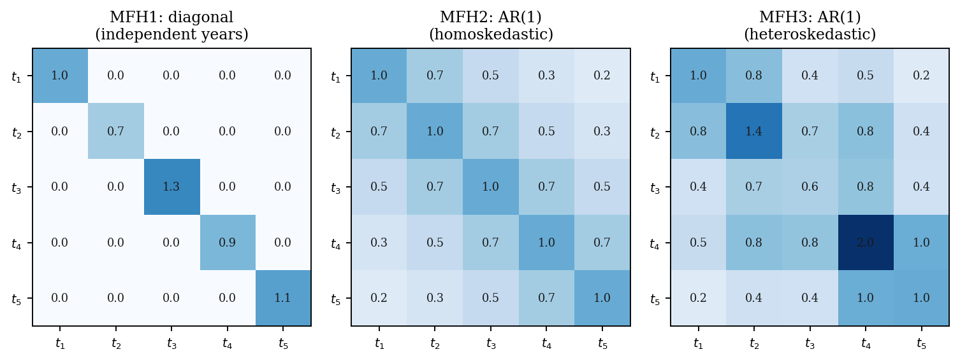
Figure 4. The three MFH random-effect covariance structures over T = 5 periods: MFH1 (diagonal / independent years), MFH2 (homoskedastic AR(1)), and MFH3 (heteroskedastic AR(1)).

8.6 Choosing among MFH1, MFH2, and MFH3
The recommended default is to start with MFH2. It provides a useful balance between flexibility and stability because it allows time correlation while keeping the covariance structure relatively parsimonious.
Recommended practice use MFH2 as the primary MFH model for the first run; use MFH1 when there is little evidence of temporal correlation in the area effects, or as a robustness check against the AR(1) assumption; use MFH3 when there is evidence that the random-effect variance differs substantially across years and the model converges reliably; avoid using MFH3 automatically, because the added flexibility may make the model unstable; compare MFH variants as a sensitivity check when feasible; and prefer the simplest model that fits the data well and produces credible estimates.
Model choice should be based on convergence, diagnostics, the plausibility of the estimated correlations and variances, comparison with UFH, and the sensitivity of the final estimates. A more complex model is not necessarily better if it produces unstable or difficult-to-interpret results.

8.7 Sampling covariance over time
When comparing estimates over time, the covariance of sampling errors matters. Sampling errors may be correlated across years if the survey uses overlapping samples, repeated PSUs, panel components, rotating panels, or other design features that create dependence across survey rounds.
This cross-year dependence has a concrete source. Households in the same primary sampling unit (PSU) share a persistent cluster effect, so whenever a survey reuses the same PSUs across rounds – through rotating panels, retained clusters, or a panel component – the two years’ direct estimates for an area become positively correlated; the covariance is zero only when the two waves are drawn independently. A practical consequence is that the covariance should be estimated from the full survey design in both rounds, not only from the re-interviewed (panel) households: because every household in a shared PSU carries the cluster effect, restricting the calculation to the linked households discards most of the covariance and understates it. With the PSUs declared as the first-stage units, an ordinary survey-design covariance command (for example, R’s survey package) estimates this quantity directly and consistently (Yoshida, 2025).
For two years $t_{1}$ and $t_{2}$, the sampling covariance for area (d) can be written as:
$$Cov(e_{dt_{1}},e_{dt_{2}}).$$
This covariance affects the uncertainty of estimated changes. The variance of the difference between two direct estimates is:
$$Var\left({\hat{θ}}_{dt_{2}}^{DIR}-{\hat{θ}}_{dt_{1}}^{DIR}\right)=Var\left({\hat{θ}}_{dt_{2}}^{DIR}\right)+Var\left({\hat{θ}}_{dt_{1}}^{DIR}\right)-2 Cov\left(e_{dt_{2}},e_{dt_{1}}\right)$$
If the covariance is ignored when it is important, confidence intervals for changes may be misleading. The direction of the effect depends on whether the covariance is positive or negative.
The app includes several covariance options:
TABLE X
Cross-Year Sampling-Covariance Options
Option | Interpretation
rho_sm_out | Estimate autocorrelation using outlier-smoothed variances.
rho_sm_all | Estimate autocorrelation using fully smoothed variances.
rho_dir | Estimate autocorrelation using direct variances.
direct | Use the direct variance-covariance matrix.
zero | Assume no cross-year sampling covariance.
As a recommended default, use a covariance option that allows cross-year correlation when PSU codes are consistent over time and sample overlap is plausible; if samples are independent across years, the zero option may be reasonable; if direct variance–covariance estimates are unstable, use the smoothed covariance options; and if unsure, run sensitivity checks using alternative covariance assumptions.
The selected covariance option should be documented because it affects uncertainty estimates for changes over time.
Two practical cautions apply. First, the variances used on the diagonal of the covariance matrix and the variances used inside its off-diagonal covariances should share the same basis; in the Dashboard the covariance options are tied to the variance option for this reason, since a value supplied on the diagonal but not in the covariance can leave a missing off-diagonal and cause the MFH fit to stop. Second, introducing non-zero covariances can make the multivariate model harder to fit. If convergence fails, the practical options, in increasing order of intervention, are to discount the covariances slightly, to replace clear outlier covariances with smoothed values (rho_sm_out), or – only as a last resort and with explicit caveats – to set the covariance to zero, recognizing that doing so leaves the uncertainty of changes over time understated (Yoshida, 2025).

8.8 Transformations and scale of estimation
In the current app workflow, MFH poverty indicators are modeled on the identity scale. Mean welfare can be modeled using the log scale or the original scale, depending on the transformation option selected.
Users should confirm that model outputs are interpreted on the correct scale. For poverty rates, estimates should remain within the feasible range from zero to one. If results fall outside this range or appear implausible, users should review the data, model specification, and diagnostics before accepting the results.
For mean welfare, log transformation may be useful when the welfare variable is highly skewed. When log transformation is used, users should apply and document the appropriate back-transformation and bias correction before reporting estimates on the original welfare scale.

8.9 MFH diagnostics
MFH estimates should not be accepted only because the model converged. Users should review diagnostics carefully because MFH imposes additional structure across time.
MFH diagnostics should include:
- Model convergence.
- Estimated time correlation.
- Estimated random-effect variance.
- Plausibility of the covariance structure.
- Residual diagnostics by year.
- Random-effect diagnostics by year.
- Comparison of direct, UFH, and MFH estimates.
- Comparison of UFH and MFH standard errors or CVs.
- Stability of area trends.
- Sensitivity to covariance assumptions.
- Sensitivity to MFH1, MFH2, and MFH3.
- Identification of areas with large model adjustments.
- Maps of estimates and uncertainty by year.
- Maps of changes over time.
A good MFH model should reduce unstable year-to-year movements caused by sampling variation without eliminating genuine changes. If MFH produces trends that are too smooth, too volatile, or inconsistent with known events, users should revisit the data, covariates, covariance assumptions, and model variant.
One diagnostic deserves particular attention under MFH2. The fitting algorithm can return a zero or near-zero random-effect variance – a boundary estimate; when this happens the area random effect drops out and the MFH estimate collapses toward the regression-synthetic prediction. A true boundary solution is possible, so a zero variance should not be rejected automatically, but it should be treated as a diagnostic warning and reviewed. In this case the Dashboard applies a constrained-REML safeguard – refitting the same MFH2 model and REML criterion under a parameterization that keeps the variance positive and the temporal correlation within its valid range, retaining the original fit when it is already admissible and flagging the areas affected (see Annex F and Annex G.9).
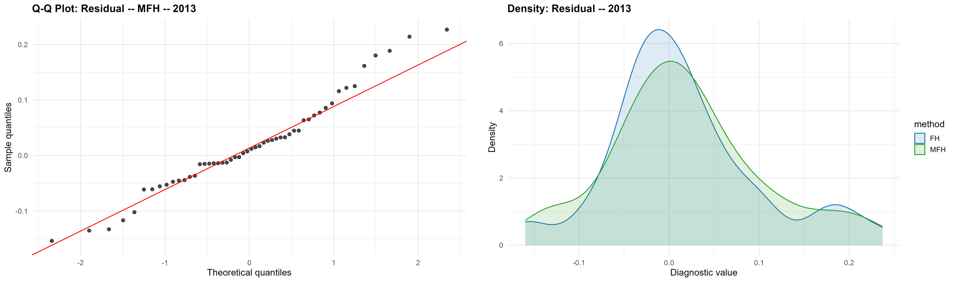
Figure 5. MFH residual diagnostics, 2013: normal Q–Q plot of the residuals (left) and the residual density for FH and MFH (right). Produced by the EU SAE Dashboard.

8.10 Interpreting MFH estimates
MFH estimates should be interpreted as model-based estimates that combine survey evidence, auxiliary data, and information about the relationship between years. They are designed to improve comparability over time, but they rely on stronger assumptions than separate UFH models do.
When interpreting MFH estimates, users should consider whether the estimated time correlation is plausible; whether MFH estimates are broadly consistent with direct and UFH estimates; whether MFH reduces unstable movements without suppressing real changes; whether areas with large changes have direct-estimate support, auxiliary-data support, or a plausible contextual explanation; whether uncertainty around changes is large; or whether results are sensitive to covariance assumptions or model variants.
MFH is often preferred for trend analysis, but only when diagnostics are satisfactory and the input data are comparable across years.

8.11 Statistical comparison over time
To compare poverty between two years, users should compute the change in poverty for each area. For area (d), the change between years $t_{1}$ and $t_{2}$ is:
$$Δ_{d}=θ_{d,t_{2}}-θ_{d,t_{1}}.$$
The estimated change is:
$$\hat{Δ}*d={\hat{θ}}_{d,t_{2}}-{\hat{θ}}_{d,t_{1}}.$$
A positive value indicates an estimated increase in poverty, while a negative value indicates an estimated decline. However, users should not interpret every estimated change as statistically meaningful. The uncertainty in the difference must account for the uncertainties in both estimates and the covariance between them.
Two ingredients therefore determine whether an estimated change is meaningful: the MSE of the estimate in each year, and the mean crossed-product error (MCPE) – the covariance of the prediction errors of the two years’ estimates for the same area. The variance of the estimated change equals the MSE in the first year plus the MSE in the second year minus twice the MCPE between them. Because the two years’ prediction errors are usually positively correlated – they share the same covariates and, in MFH, the same area random effect – the MCPE is typically positive and reduces the variance of the change. Ignoring it would overstate the uncertainty of changes and make genuine movements in poverty harder to detect. The MCPE is therefore essential for valid inference over time, and the Dashboard estimates it by bootstrap alongside the MSE.
Operationally, users should report estimated poverty in the first year; estimated poverty in the second year; estimated change in percentage points; standard error of the change; confidence interval for the change; whether the confidence interval includes zero; and a flag for statistically significant increase, decrease, or no statistically significant change.
Users should avoid overinterpreting small changes when uncertainty is large. Maps of changes should distinguish statistically significant changes from those that are not.
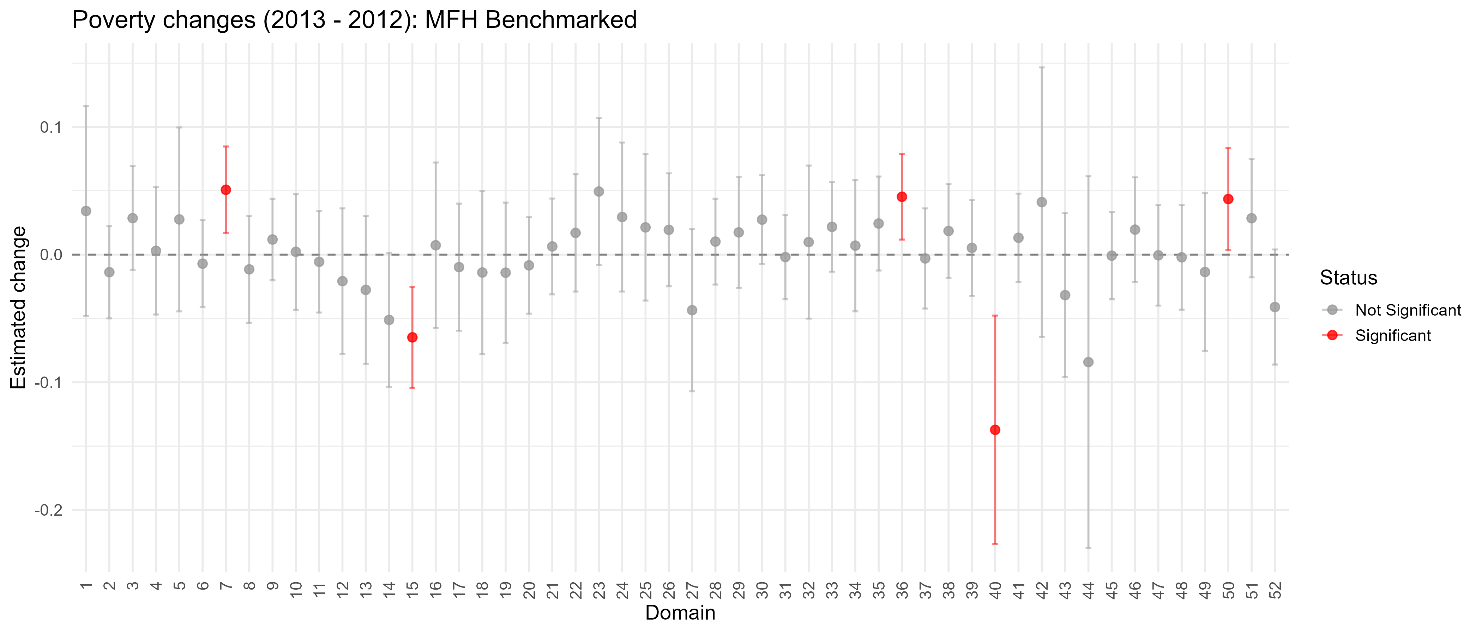
Figure 6. Domain-level change in the poverty rate between 2012 and 2013 and its statistical significance (benchmarked MFH); changes that are not statistically distinguishable from zero are identified. Produced by the EU SAE Dashboard.

8.12 MFH outputs
The MFH stage should produce outputs that support both cross-sectional mapping and time-comparison analysis. These outputs should include:
- Area-year MFH estimates.
- Standard errors or MSEs.
- Coefficients of variation.
- Estimated changes between selected years.
- Standard errors and confidence intervals for changes.
- Significance flags for increases and decreases.
- Comparison tables with direct and UFH estimates.
- Model diagnostics.
- Selected covariates.
- Estimated covariance or correlation parameters.
- Maps by year.
- Maps of changes over time.
- Maps of statistically significant changes.
- Output files for the comparison stage.
MFH outputs should retain direct and UFH estimates alongside MFH estimates. This allows users to assess whether MFH changes the results substantially and whether those changes are justified by the model and data.

8.13 MFH checklist
Before accepting MFH results, users should confirm that:
- Two or more comparable survey years are available.
- Domain definitions are consistent across years or have been harmonized.
- Welfare variables and poverty lines are comparable across years.
- Direct estimates and sampling variances have been reviewed for all area-year cells.
- Auxiliary variables are available and comparable across years.
- The selected MFH variant converged successfully.
- The estimated time correlation is plausible.
- Random-effect variances are plausible.
- Residuals and random effects do not show major problems.
- MFH estimates are compared with direct and UFH estimates.
- Large differences between UFH and MFH estimates are investigated.
- Time trends are plausible in light of the country context.
- Covariance assumptions have been reviewed.
- Sensitivity checks have been conducted where feasible.
- Estimated changes are reported with standard errors and confidence intervals.
- Maps of changes distinguish statistically significant and non-significant changes.
- Limitations are documented.
MFH results should be treated as provisional until these checks have been completed. When diagnostics are weak or results are highly sensitive to reasonable model choices, MFH should not be used as the preferred estimate without further review.

9. Comparing UFH and MFH Results

9.1 Purpose of the comparison stage
The comparison stage is a central part of quality assurance. UFH and MFH estimates should not be accepted simply because the models run successfully. They should be compared with each other and with the direct estimates to assess whether the final results are credible, stable, and suitable for reporting.
Direct estimates provide the survey-only evidence. UFH estimates show the cross-sectional model-based results for each year. MFH estimates show the model-based results when information is borrowed across both areas and time. Comparing the three helps users understand how much each modeling step changes the results and whether those changes are reasonable.
The comparison stage should answer four practical questions:
- Are the model-based estimates broadly consistent with the direct survey evidence?
- Do UFH and MFH improve precision without producing implausible estimates?
- Does MFH improve time comparability relative to separate UFH models?
- Are the final recommended estimates robust enough for mapping, reporting, and policy use?
If the answer to any of these questions is unclear, users should review the input data, model specification, covariance assumptions, and diagnostics before finalizing results.

9.2 Why comparison is necessary
MFH should not be accepted mechanically as the preferred estimate. Although MFH can improve stability over time, it also imposes additional assumptions about the relationship between years. These assumptions are useful when supported by the data, but they can be misleading if the input data are not comparable across years or if the estimated temporal correlation is implausible.
Comparison is especially important when the number of areas is small; direct estimates are noisy; many areas have small sample sizes; covariates are weak or unstable; domain definitions changed over time; welfare variables or poverty lines are not fully comparable across years; MFH and UFH estimates differ substantially; some areas show large estimated changes over time; MFH produces very smooth or very volatile trends; or model outputs are sensitive to covariance assumptions or model variants.
In these cases, comparison helps determine whether MFH adds useful information or imposes structure that is not adequately supported by the data.

9.3 Main dimensions of comparison
The comparison should cover both point estimates and uncertainty measures. Users should review the following dimensions.
Point estimates. Compare direct, UFH, and MFH estimates by area and year. Large differences should be investigated, especially when the direct estimate is precise.
Standard errors and coefficients of variation. Compare uncertainty measures across direct, UFH, and MFH estimates. Model-based estimates should usually reduce uncertainty, but large precision gains should be checked to ensure they are not driven by implausible model assumptions.
Precision gains. Assess whether UFH and MFH improve precision relative to direct estimates, particularly in areas with small samples or high direct-estimate CVs.
Area rankings. Review whether rankings change substantially across direct, UFH, and MFH estimates. Rankings should be interpreted cautiously when confidence intervals overlap.
Maps.
Compare maps of direct, UFH, and MFH estimates. Maps can reveal spatial patterns, outliers, or discontinuities that are not obvious in tables.
Uncertainty maps. Compare CV maps, standard error maps, or confidence-interval-width maps. These maps show where estimates are strong and where they remain uncertain.
Time trends. Compare UFH and MFH trends for each area. MFH should reduce noise-driven instability, but it should not eliminate genuine changes.
Estimated changes. Compare changes over time using UFH and MFH estimates. Changes should be accompanied by standard errors and confidence intervals.
Statistical significance of changes. Review whether estimated increases or decreases are statistically meaningful. Change maps should distinguish significant changes from changes that are not statistically significant.
Benchmark consistency. If benchmarking is used, compare estimates before and after benchmarking and check whether the adjustment materially changes results.
Diagnostic flags. Review areas with large model adjustments, high uncertainty, unstable trends, outlier residuals, or sensitivity to model settings.

9.4 Comparing direct and UFH estimates
The comparison between direct and UFH estimates shows how much the cross-sectional model changes the survey-only evidence. This comparison should be conducted separately for each year.
Users should expect larger differences between direct and UFH estimates in areas where direct estimates have high sampling variances. Smaller differences are expected in areas where direct estimates are precise.
Large differences between direct and UFH estimates may be acceptable when the direct estimate has a large standard error or high CV; the area has a small sample size; the auxiliary variables strongly indicate a different poverty level; neighboring or similar areas show a consistent pattern; or the UFH estimate remains plausible in the country context.
Large differences require further review when the direct estimate is precise; the UFH estimate strongly conflicts with the direct evidence; the selected covariates are weak or difficult to interpret; the area is an outlier in the residual diagnostics; or the model produces implausible spatial patterns.
The objective is not for UFH to reproduce direct estimates exactly. The objective is for UFH to improve precision while remaining anchored in the survey evidence.

9.5 Comparing UFH and MFH estimates
The comparison between UFH and MFH estimates shows the effect of borrowing strength across time. This comparison is especially important when MFH is being considered as the preferred estimate for trend analysis.
If UFH and MFH estimates are similar, this increases confidence that the time-correlation structure is not materially changing the results. If MFH is smoother than UFH, this may indicate that MFH is reducing sampling noise over time. This is often desirable when direct estimates are noisy and year-to-year movements are implausibly volatile.
However, large differences between UFH and MFH should be investigated. Users should check whether direct estimates are noisy in the relevant areas or years, UFH estimates are unstable because each year is modeled separately, MFH is imposing excessive smoothness over time, a real shock or policy change may justify a large change, covariates are comparable and consistently measured across years, the estimated time correlation is plausible, and results are sensitive to the MFH variant or covariance option.
MFH should improve comparability over time, but it should not suppress genuine changes in poverty. If MFH removes changes that are supported by survey evidence, auxiliary data, and country context, users should revisit the model specification.
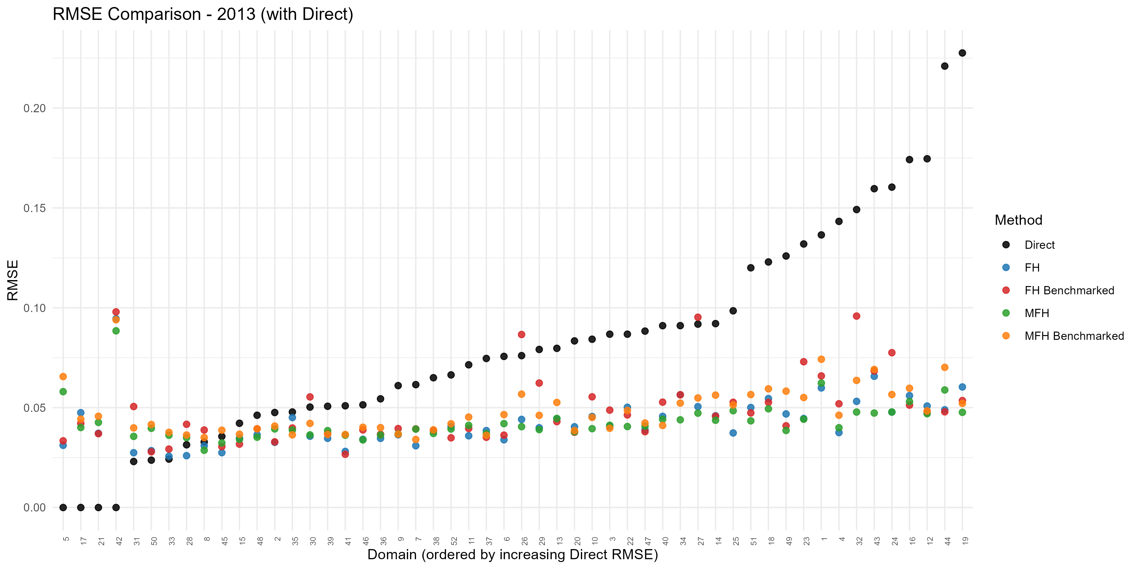
Figure 7. Domain-level root mean squared error (RMSE) by method, 2013; the FH and MFH estimates have markedly lower RMSE than the direct estimates. Produced by the EU SAE Dashboard.

9.6 Interpreting differences among estimates
Differences among direct, UFH, and MFH estimates should be interpreted in light of both sampling uncertainty and model assumptions.
A useful interpretation framework is Direct estimate differs from UFH/MFH, but direct uncertainty is high: the model-based adjustment may be reasonable; Direct estimate differs from UFH/MFH, and direct uncertainty is low: investigate the model and covariates carefully; UFH and MFH are similar: the final results are likely robust to the time-correlation structure; MFH is smoother than UFH: this may indicate useful stabilization, especially when UFH trends are noisy; MFH differs sharply from UFH: review covariance assumptions, model diagnostics, and country context; MFH shows no change despite strong evidence of change: check whether the model is oversmoothing; and MFH shows large changes not visible in direct or UFH estimates: check whether the model is unstable or driven by covariates.
Users should avoid treating any single estimate as automatically correct. The preferred estimate should be chosen after reviewing the full pattern of evidence.

9.7 Choosing final estimates
The choice of final estimates should depend on the objective of the poverty mapping exercise and the quality of diagnostics.
Recommended practice use direct estimates for transparency, validation, and comparison; use UFH as the main model-based estimate when the objective is a single-year poverty map; use UFH as the cross-sectional benchmark even when MFH is used; use MFH as the preferred estimate when the objective is comparable poverty maps over time, provided diagnostics are satisfactory; do not use MFH as the preferred estimate if input data are not comparable across years, the model does not converge, time-correlation estimates are implausible, or results are highly sensitive to reasonable modeling choices; report uncertainty measures alongside all final estimates; and clearly document why the preferred estimate was selected.
In many applications, the final report may present MFH estimates as the preferred estimates for time comparisons while also showing UFH and direct estimates in annex tables. This approach preserves transparency and allows technical reviewers to assess the effect of modeling choices.

9.8 Recommended comparison tables
The comparison stage should produce tables that allow users to review estimates, uncertainty, and differences across methods. Recommended tables include:
TABLE XI
Recommended Comparison Tables
Table | Purpose
Direct, UFH, and MFH estimates by area-year | Shows all main estimates together.
Standard errors and CVs by method | Compares uncertainty across methods.
UFH minus direct differences | Shows cross-sectional model adjustments.
MFH minus UFH differences | Shows the effect of borrowing strength over time.
Estimated changes over time | Shows area-level changes between two years.
Confidence intervals for changes | Distinguishes meaningful changes from uncertain changes.
Diagnostic flags | Identifies areas requiring review.
Benchmark comparison | Shows the effect of benchmarking, if used.
These tables should be reviewed before maps are produced for publication. Maps are useful for communication, but tables are often better for diagnosing the size and source of differences.

9.9 Recommended comparison figures and maps
Figures and maps can help identify patterns that are difficult to see in tables. Recommended outputs include:
- Scatter plot of direct versus UFH estimates.
- Scatter plot of UFH versus MFH estimates.
- Scatter plot of direct versus MFH estimates.
- Maps of direct estimates.
- Maps of UFH estimates.
- Maps of MFH estimates.
- Maps of standard errors or CVs.
- Maps of UFH-minus-direct differences.
- Maps of MFH-minus-UFH differences.
- Maps of estimated changes over time.
- Maps of statistically significant increases and decreases.
- Trend plots for selected areas.
When comparing maps over time, users should use common class intervals so that the same color represents the same poverty range in each year. Maps of changes should always be accompanied by uncertainty information.

9.10 Diagnostic flags for review
The comparison stage should identify areas that require additional review. Suggested flags include:
- Very small sample size.
- Missing direct estimate.
- Zero or one direct estimate.
- High direct-estimate CV.
- Zero, missing, or smoothed sampling variance.
- Large UFH-minus-direct difference.
- Large MFH-minus-UFH difference.
- Large estimated change over time.
- Statistically significant increase or decrease.
- Large change that is not statistically significant.
- Outlier residual.
- High final CV or wide confidence interval.
- Area affected by boundary changes.
- Area affected by known shock, conflict, disaster, or policy change.
These flags should not automatically exclude an estimate. They are intended to guide technical review and interpretation.

9.11 Documenting the comparison
The final report should explain how direct, UFH, and MFH estimates were compared and how the preferred estimates were chosen. The documentation should include the purpose of the comparison; the methods compared; the main differences among direct, UFH, and MFH estimates; the effect of MFH on time trends; the effect of benchmarking, if used; diagnostics reviewed; sensitivity checks conducted; areas or years requiring caution; and justification for the final recommended estimates.
A short narrative should accompany the tables and maps. For example, the report may state that MFH was selected as the preferred estimate because it improved stability over time, reduced uncertainty, and produced results broadly consistent with direct and UFH estimates. If some areas show large adjustments or high uncertainty, these should be explicitly noted.

9.12 Comparison-stage checklist
Before finalizing estimates, users should confirm that:
- Direct, UFH, and MFH estimates have been compared side by side.
- Standard errors, CVs, and confidence intervals have been reviewed.
- Large differences between direct and UFH estimates have been investigated.
- Large differences between UFH and MFH estimates have been investigated.
- Estimated time trends are plausible.
- Change estimates include standard errors and confidence intervals.
- Statistically significant and non-significant changes are clearly distinguished.
- Maps use consistent class intervals across years.
- Uncertainty maps are reviewed alongside point-estimate maps.
- Diagnostic flags are reviewed.
- Sensitivity checks are documented.
- The preferred estimate is justified.
- Limitations are clearly stated.
The comparison stage should be completed before producing final maps and before recommending estimates for publication or policy use.

10. Preparing Poverty Maps

10.1 Mapping estimates
A poverty map is produced by joining the small-area estimates to the geographic boundaries on the shared area code and shading each area by its estimated poverty. The join is only as good as the consistency of the area codes (Section 4.1); a single mismatched code leaves an area blank or, worse, mislabelled. The Dashboard performs this join automatically using the geometry supplied at upload and produces the maps as part of every run.
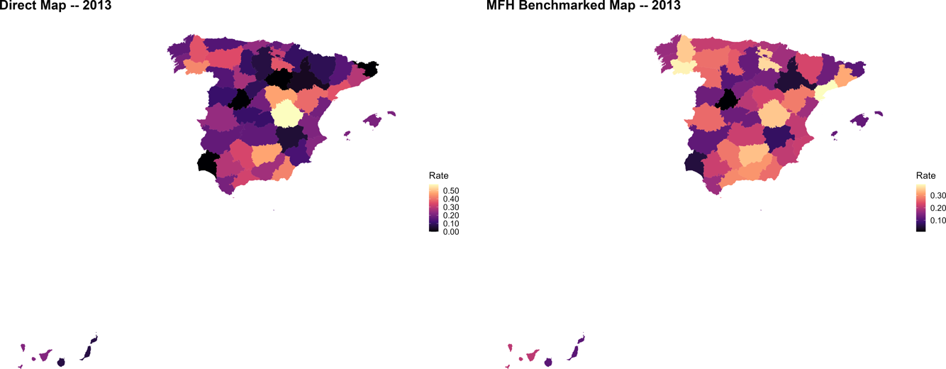
Figure 8. Poverty rate by province, 2013: direct estimates (left) and benchmarked MFH estimates (right). The MFH map is smoother and more precise. Produced by the EU SAE Dashboard.

10.2 Mapping uncertainty
A map of point estimates alone can mislead, because it gives every area the same visual authority regardless of how precisely it is estimated. Always accompany the estimate map with a map of uncertainty — typically the coefficient of variation, or alternatively the width of the confidence interval. Reading the two together shows not only where poverty is high but where the evidence for it is strong, and it prevents readers from over-interpreting areas whose estimates are imprecise.

10.3 Mapping changes over time
When two or more years are analyzed, a map of the change in poverty is often the most policy-relevant output. Such a map should distinguish changes that are statistically meaningful from those that are not: shading an area by its estimated change without regard to significance invites readers to see movement where there is only noise. The recommended practice is to map the change but to mark — by hatching, desaturation, or a separate significance map — those areas whose change is not distinguishable from zero under the test of Section 8.7. The Dashboard produces both the change maps and the supporting significance assessment.
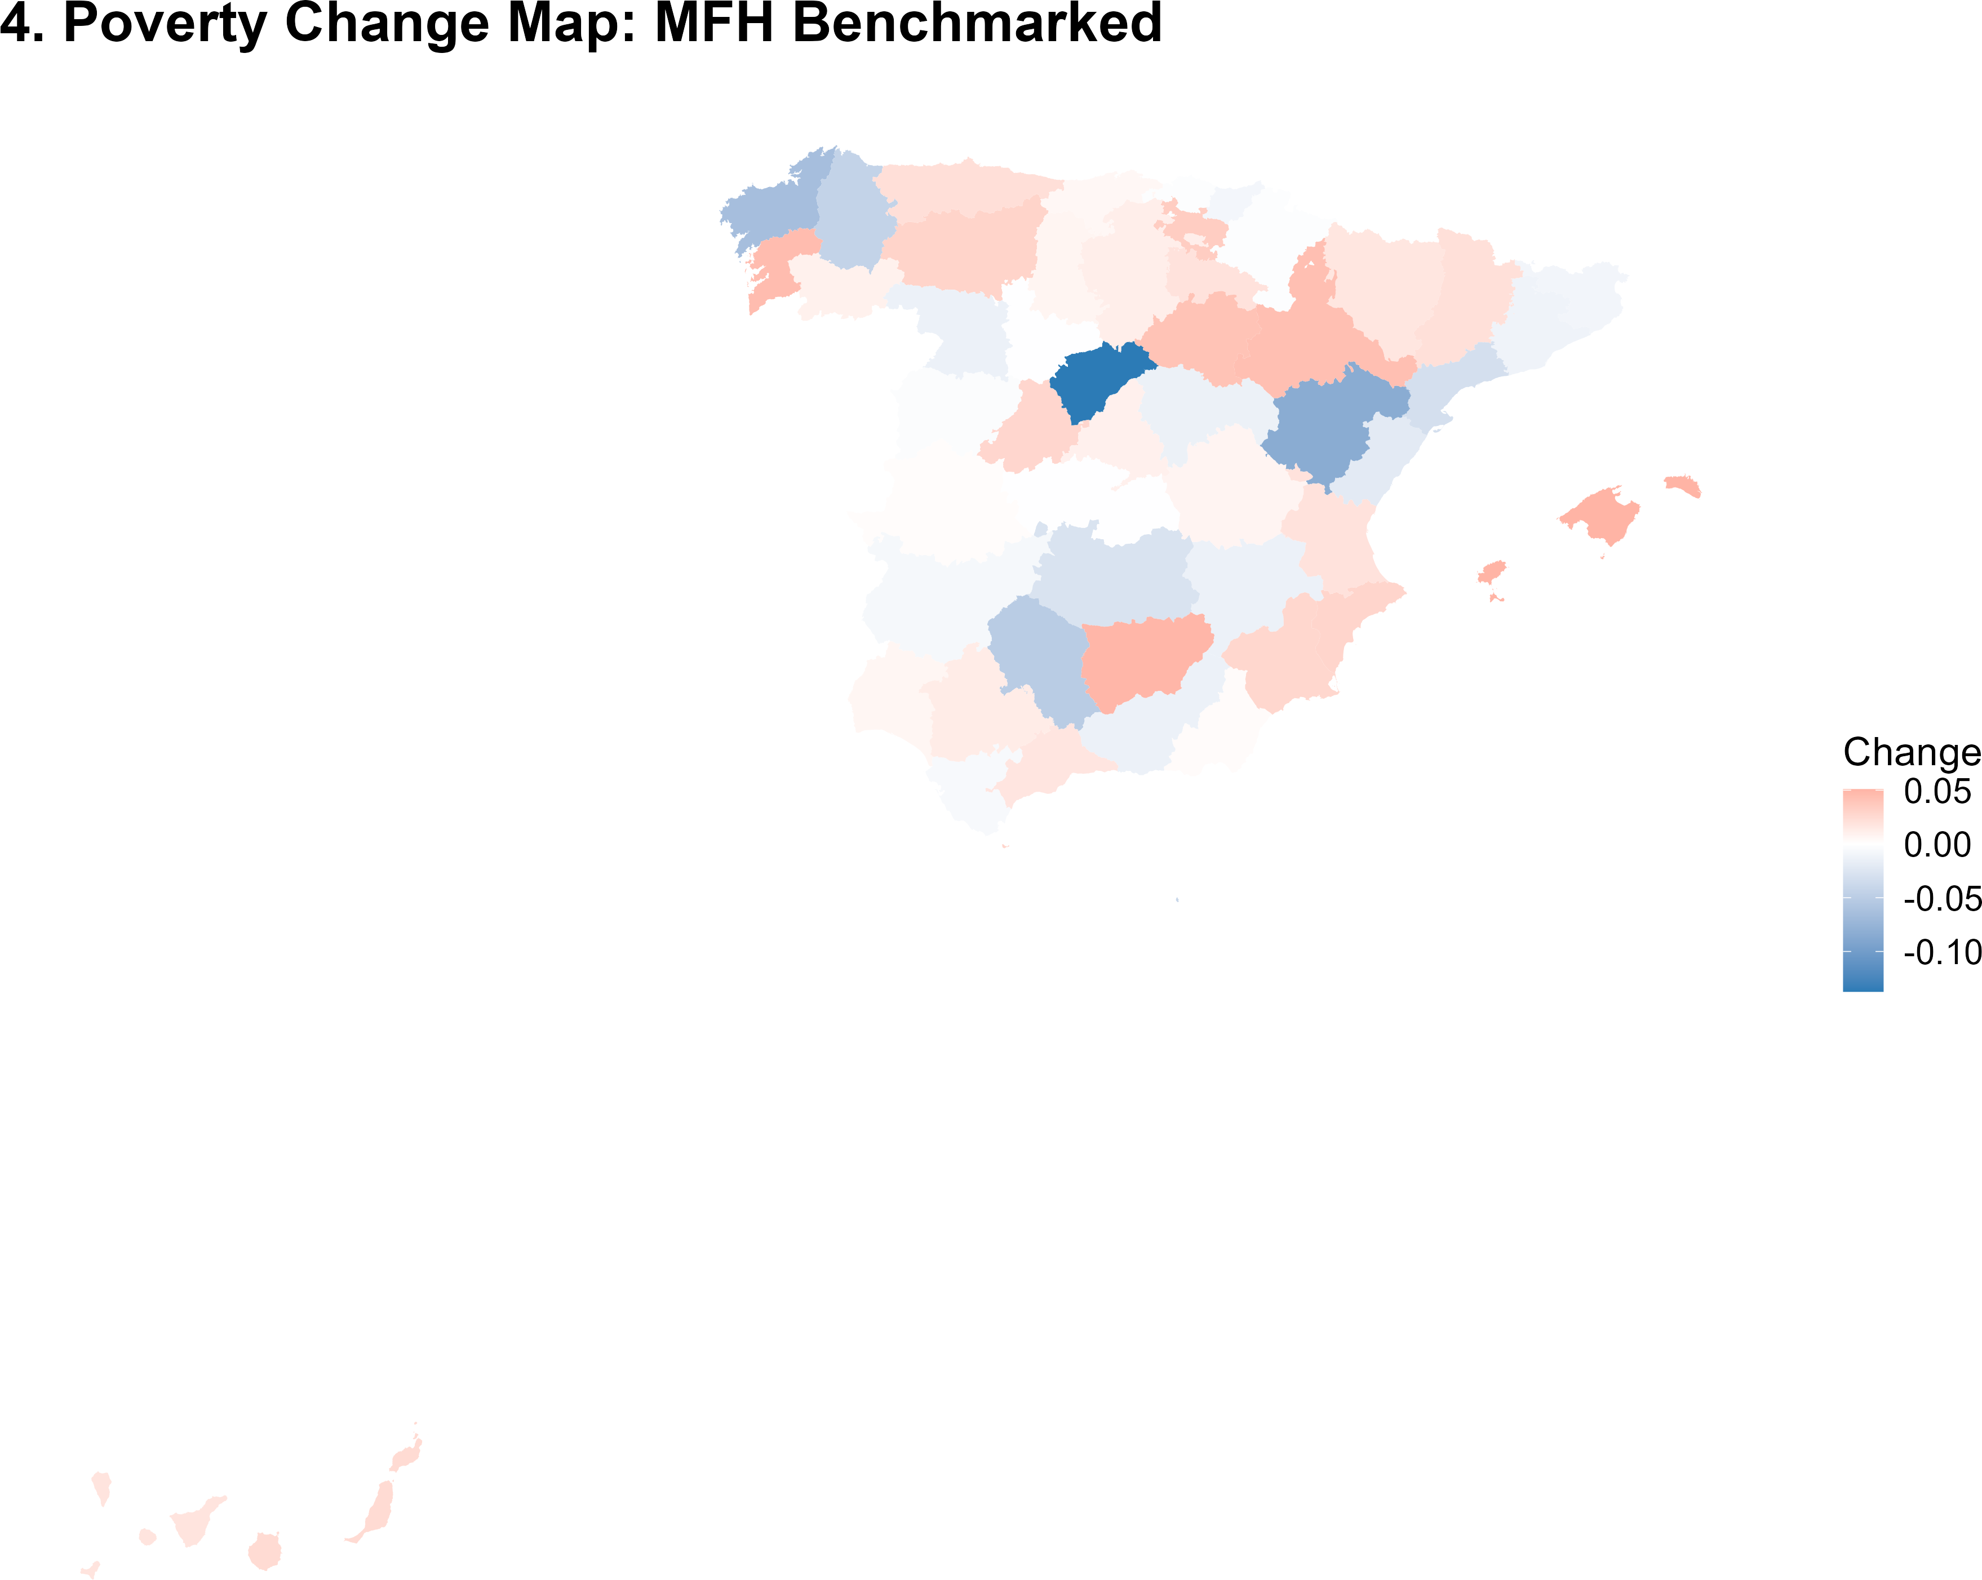
Figure 9. Map of the estimated change in the poverty rate between 2012 and 2013 (benchmarked MFH).

10.4 Class intervals and legends
Use consistent class intervals across years and across methods. If the maps for 2012 and 2013, or the UFH and MFH maps for the same year, use different breaks or color scales, the reader cannot compare them visually and may perceive differences that are artifacts of the legend. Fix the intervals once — by a defensible rule such as quantiles of the pooled distribution, equal intervals, or substantively meaningful thresholds — and apply them to every map in the set. Choose a color ramp that is perceptually uniform and legible to readers with color-vision deficiency.

10.5 Avoiding misleading maps
Three cautions recur. First, do not over-interpret small differences between areas whose estimates have overlapping confidence intervals. Second, beware the visual weight of large but sparsely populated areas, which can dominate a map while representing few people; a cartogram or a population-referenced reading can help. Third, never present a change map without conveying uncertainty. A poverty map is a powerful communication device precisely because it is read quickly and intuitively, which is also why a misleading one does damage quickly; the uncertainty information is not an optional technical addendum but part of the map’s honest meaning.

11. Using the Shiny Application
The EU SAE Dashboard is a single R Shiny application that runs the entire workflow of this note — direct estimation, UFH, MFH, comparison, mapping, diagnostics, and reporting — through a graphical interface. This section documents the application screen by screen. The companion slide deck covers the same ground visually and is the recommended quick-start.

11.1 Installing and launching the app
The only prerequisite is R version 4.2 or later (no RStudio is required). After downloading and extracting the package, the folder contains the application and its supporting parts:
eu-sae-dashboard/
├── app.R # the Shiny application
├── Start_Dashboard.bat # one-click launcher (Windows)
├── Start_Dashboard.sh # one-click launcher (macOS / Linux)
├── install_packages.R # one-time package installer
├── R/ # helper modules (validation, diagnostics, AI, reporting)
├── scripts/ # the UFH, MFH, and comparison pipelines
├── data/ # sample data and geometry
├── outputs/ # figures, tables, and data written by each run
└── www/ # static assets
On the first launch, Start_Dashboard.bat (or .sh) runs install_packages.R, which checks for and installs the required packages — among them shiny, the SAE engines sae, msae, and emdi, the survey package survey, the spatial packages sf and spdep, and the visualization and reporting packages ggplot2, gt, and rmarkdown. The installer only downloads what is missing, so subsequent launches are fast. The application can also be started from an R session with shiny::runApp("app.R"). Upon opening, a cover screen leads to a short in-app guide, then to the main workspace.
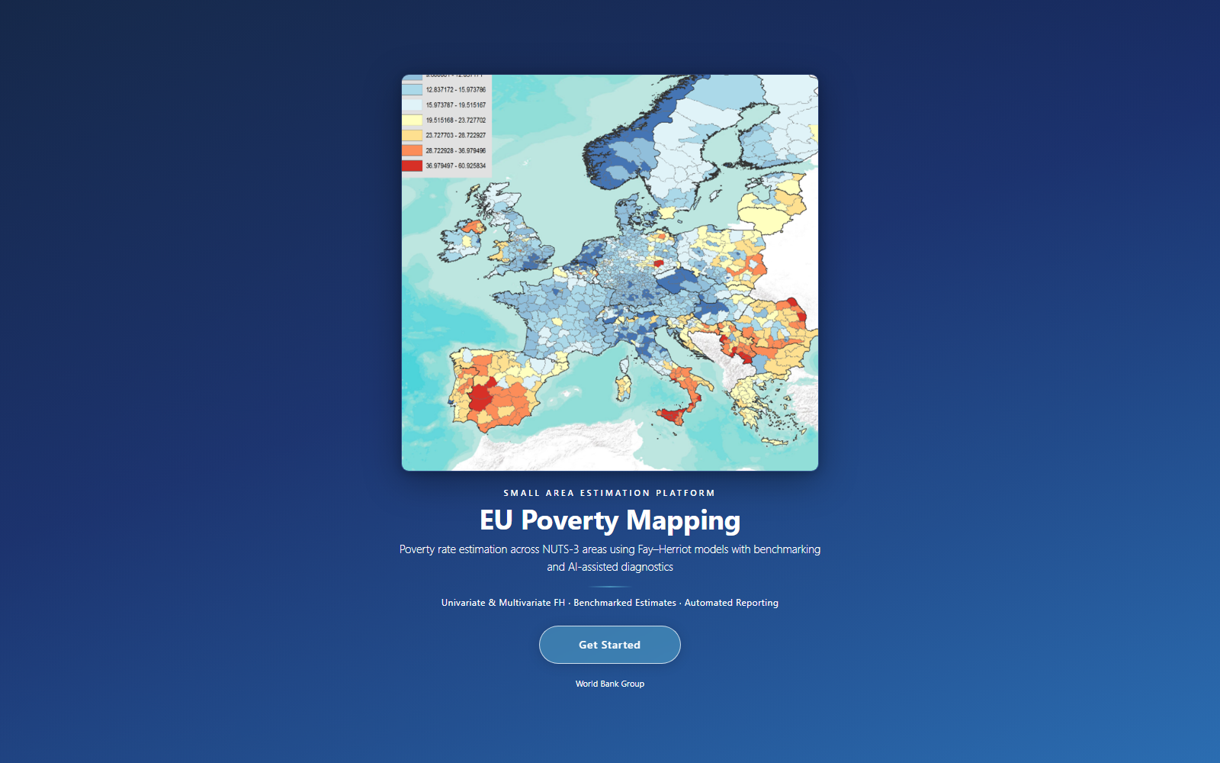
Figure 10. The EU SAE Dashboard landing screen; Get Started opens the in-app guide and main workspace. Produced by the EU SAE Dashboard.

11.2 App workflow
The analysis is organized as a three-stage pipeline, selectable in the sidebar UFH — fits a univariate Fay–Herriot model independently for each year (the baseline); MFH — fits the multivariate models (MFH1, MFH2, and optionally MFH3) jointly across years; and Comparison — merges the UFH and MFH results side by side with maps, scatter plots, precision metrics, and model diagnostics.
Internally, these correspond to the three scripts 01_ufh.R, 02_mfh.R, and 03_comparison.R, run in sequence.
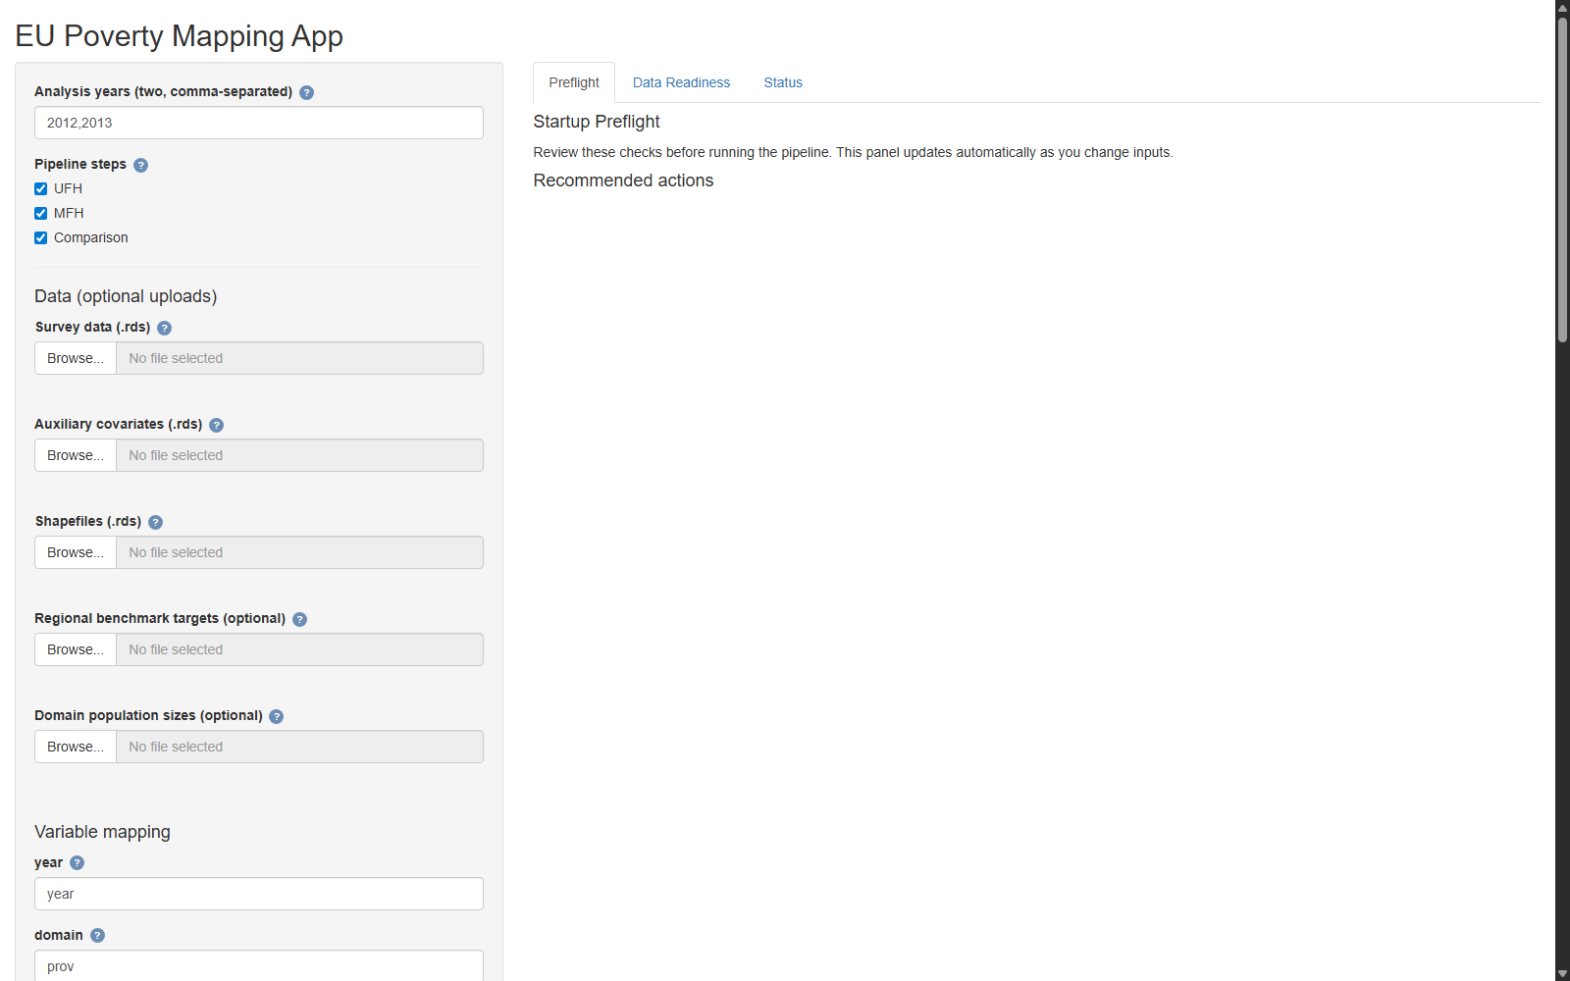
Figure 11. The main workspace: analysis settings and optional data uploads in the sidebar, with Preflight, Data Readiness, and Status tabs on the right. Produced by the EU SAE Dashboard.
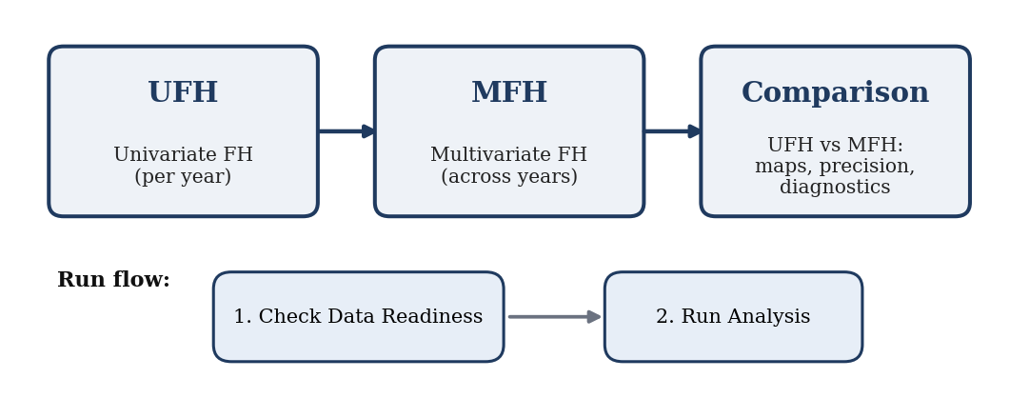
Figure 12. The EU SAE Dashboard pipeline and two-step run flow.

11.3 Uploading input data
The sidebar accepts the input files described in Section 3 survey data (household microdata; .rds, .csv, or Excel);; auxiliary data (area–year aggregates);; population sizes (by area and year);; geometry (boundaries for mapping); and; and optionally, pre-computed direct estimates, if the analyst prefers to supply them rather than have the app recompute them from the microdata.
If no files are supplied, the app falls back to the bundled sample data (subnational data with provincial boundaries), which is useful for learning the workflow.

11.4 Variable mapping
After the survey file is loaded, the app asks the analyst to identify which columns correspond to which roles: the year, the domain (area), the weight, the welfare variable, the poverty line, the PSU, and the auxiliary variables. This mapping step is what lets the same application work with data from any country and any naming convention; it is also where most user errors are caught early, because a column assigned to the wrong role usually shows up immediately in the readiness check.
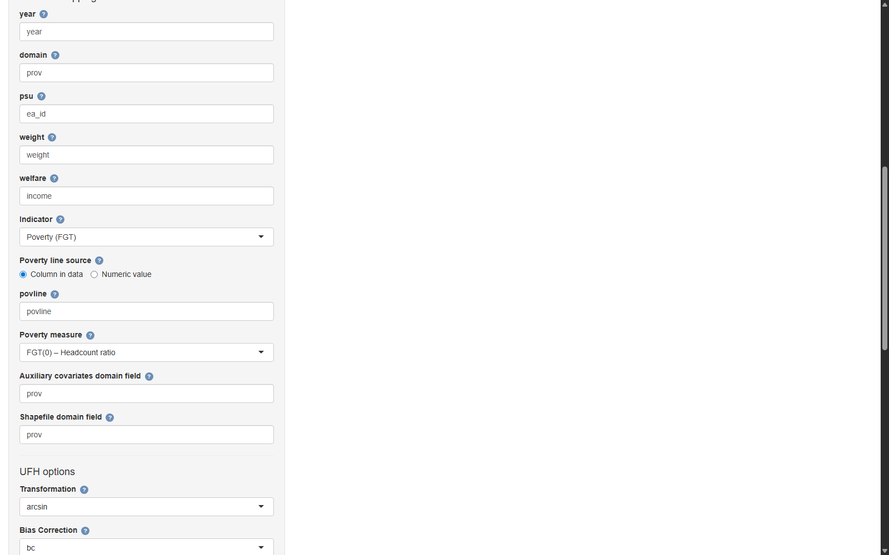
Figure 13. Variable mapping: assigning survey columns to their roles (year, domain, PSU, weight, welfare, poverty line, and auxiliary fields). Produced by the EU SAE Dashboard.

11.5 Selecting the indicator
The Indicator selector chooses what is modeled. Poverty (FGT) uses the welfare variable and a poverty line to compute the headcount, gap, or severity (the FGT order is then chosen separately). Mean welfare models the survey-weighted mean of the welfare variable directly. Selecting Mean welfare hides the poverty-line inputs, which are irrelevant in that case, and exposes the log-transformation options instead.

11.6 Choosing the poverty line
For the poverty indicator, the poverty-line source can be either a column in the survey data (allowing the line to vary by household, region, or year) or a fixed numeric value applied to all observations, entered directly in the app. This mirrors the two options of Section 4.3.

11.7 Choosing transformations
The transformation options follow Section 7.3 and are context-aware. For poverty rates, the choice is arcsin (default, constrains estimates to $[0,1]$ and stabilizes variances) or no transformation. For mean welfare, the choice is log (addresses right-skew, with a bias-corrected back-transform to currency) or no transformation. The UFH and MFH transformations are set independently.

11.8 UFH settings
The univariate stage exposes Transformation — arcsin / no (poverty) or log / no (mean welfare);; Bias Correction — bc for arcsin, bc_sm (Duan’s smearing) for log, or none;; Variance option — sm_out (default), sm_all, or direct, effective only when no transformation is used;; Model selection criterion — BIC (default) or AIC for stepwise covariate selection; and; and Manual covariate candidates — an optional explicit list of covariates to consider.

11.9 MFH settings
The multivariate stage exposes Transformation (mean welfare only) — log / no, independent of the UFH choice; for poverty rates the MFH stage always works on the identity scale (arcsin is not used multivariately);; Bias Correction (log only) — bc_sm (Duan’s smearing) or none;; Model selection criterion — AIC (default) or BIC;; Variance option — sm_out, sm_all, or direct;; Covariance option — how the cross-year sampling covariance is built (rho_sm_out, rho_sm_all, rho_dir, direct, or zero); the available choices update automatically to stay consistent with the variance option (Section 8.5);; Diagnostic model — which variant (MFH1 / MFH2 / MFH3) drives the comparison report end to end; and; and Try MFH3 — whether to also fit the heteroskedastic AR(1) model, and Manual covariate candidates as in the univariate stage.
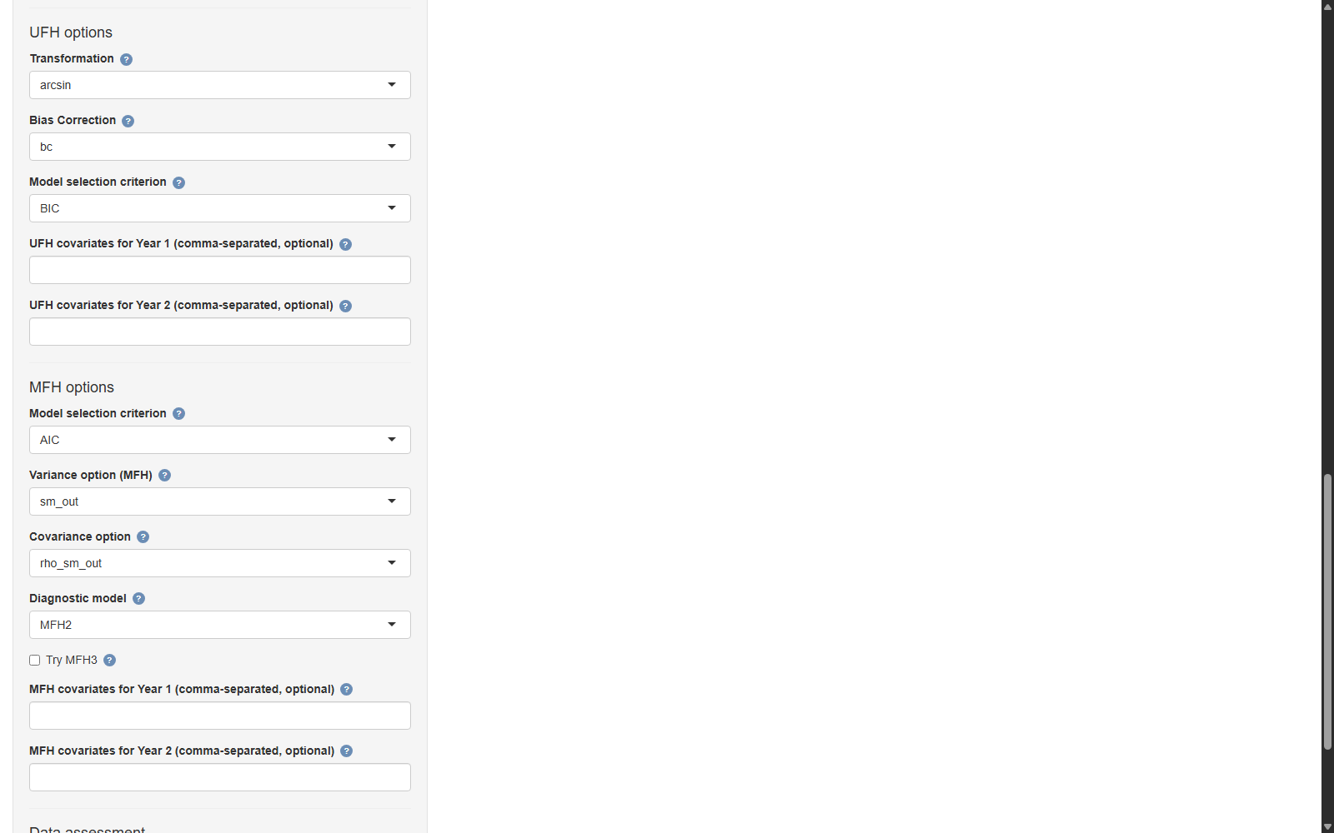
Figure 14. Model settings: UFH transformation, bias-correction and model-selection controls, plus MFH variance, covariance, diagnostic-model, and candidate-covariate controls. Produced by the EU SAE Dashboard.

11.10 Data readiness check
Before any model is fitted, the app runs a set of automatic readiness diagnostics and reports them on the Preflight and Data Readiness tabs. They cover missing variables — whether every column named in the variable mapping is present;; domain consistency — whether the set of area codes agrees across the survey, auxiliary, population, and geometry files;; missing poverty rates — which area–year cells lack a survey-based direct estimate;; auxiliary covariate summary — the mean, dispersion, observation count, and correlation with the target indicator for each numeric covariate;; national poverty rates — the implied national headcount for each year, as a sanity check against known figures; and; and recommended actions — concrete suggestions where a check raises a concern.
These diagnostics are the single most valuable habit in the whole workflow: most failed or misleading runs are prevented here, before any modeling effort is spent.
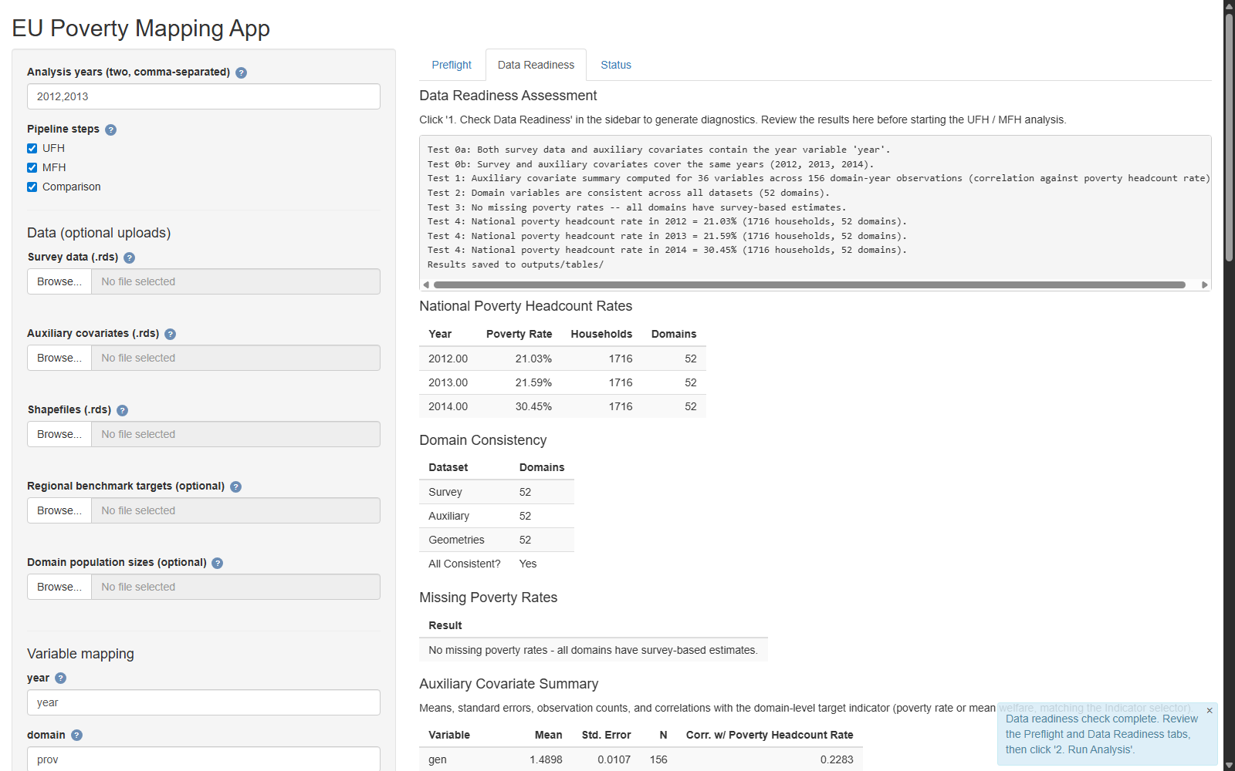
Figure 15. The mandatory Data Readiness check: year consistency, domain consistency, missing rates, auxiliary-covariate summaries, and national poverty rates. Produced by the EU SAE Dashboard.

11.11 Running the analysis
Running the analysis is deliberately a two-step action in the sidebar. First, “1. Check Data Readiness” runs the diagnostics above without doing any modeling. Only after the analyst has reviewed and is satisfied with the readiness output should they click “2. Run Analysis,” which executes the UFH, MFH, and comparison stages in sequence. Separating the two steps enforces the discipline of looking at the data before trusting the model.

11.12 Reviewing app outputs
Results appear across the output tabs and in the outputs folder Preflight and Data Readiness — the checks of Section 11.10, with the national-rate, domain-consistency, missing-rate, and auxiliary-summary tables; Status — the current pipeline step, a live run log, and a table of expected outputs with an indicator of whether each file has been produced; Maps, diagnostics, and comparison reports — the figures and tables written to outputs/figures, outputs/tables, and outputs/data, including the per-year UFH and MFH maps, CV maps, change maps, the direct-versus-UFH and UFH-versus-MFH scatter plots, the residual and Q–Q diagnostics, and the side-by-side comparison; and Analysis brief — a narrative summary of the run that can serve as the first draft of the methods-and-results text in the final report.
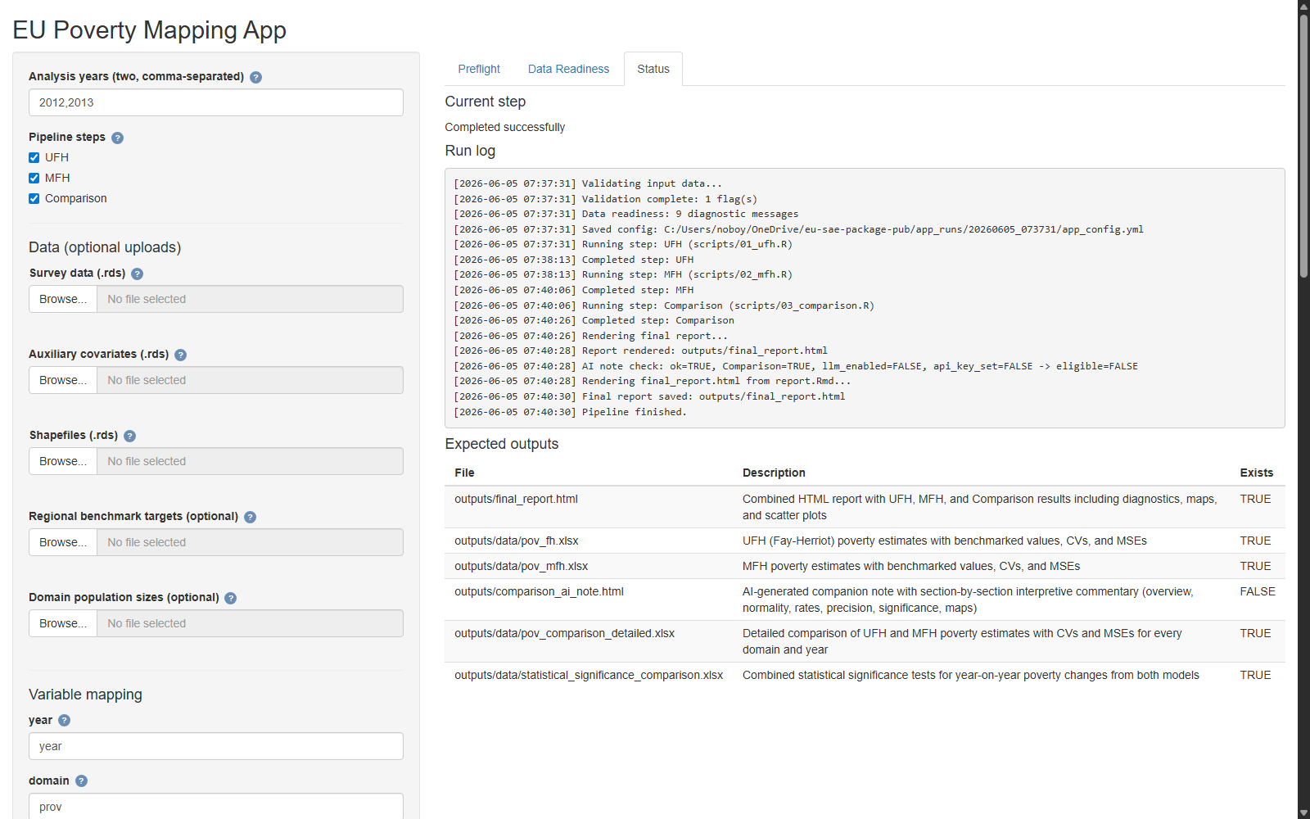
Figure 16. Reviewing outputs: the Status tab shows the run log and confirms which report, diagnostics, map, and comparison files were produced. Produced by the EU SAE Dashboard.

11.13 AI-assisted diagnostics
The Dashboard can optionally connect to a large-language-model assistant (via a Claude or ChatGPT API key pasted into the app) that helps interpret the diagnostics and drafts narrative summaries of the run. This is a convenience for turning numbers into prose, not a substitute for the analyst’s judgment. A data-protection caution applies: only aggregate statistics — model summaries, diagnostic values, area-level estimates — should ever be sent to an external service, never household microdata, and the analyst remains responsible for ensuring that even aggregate sharing complies with the data-governance rules of their institution and the data provider. When in doubt, the assistant should be left disconnected, and the diagnostics should be interpreted manually using this note.

12. Quality Assurance and Validation

12.1 Internal consistency checks
Confirm that the building blocks line up before drawing conclusions: that domain codes, years, population totals, and covariates are consistent across all data sources. The readiness check (Section 11.10) automates much of this, but the analyst should still inspect the domain-consistency and national-rate tables directly. A mismatch here invalidates everything downstream, however good the model.

12.2 Direct estimate checks
Review the direct estimates that feed the model: flag areas with high CVs, with zero or implausibly small sampling variances, with missing values, or with extreme estimates. These are the inputs the model treats as data and as known error variances, so a defect here propagates into the model-based estimates. Decide explicitly how each flagged area is handled — smoothed variance, exclusion, or a note in the documentation.
For change analysis, also confirm that the cross-year sampling-covariance option matches the survey design (Section 8.7): an inappropriate covariance assumption distorts the uncertainty of changes even when the level estimates look fine.

12.3 Model diagnostics
Work through the diagnostics of Sections 7.9 and 8.9: residual and random-effect normality, outlying areas, convergence, admissibility of the variance components, and sensitivity to the chosen transformation. A model that fails these checks should not be published even if its point estimates look reasonable.
It helps to distinguish three kinds of diagnostic signal: those pointing to data problems (mismatched codes, implausible direct estimates, unstable variances), those pointing to model problems (non-normal residuals, a boundary variance component, non-convergence), and those pointing to interpretation or reporting limits (high CVs, wide change intervals, sensitivity to model choices). Each calls for a different response – fix the data, reconsider the model, or qualify the claim.

12.4 Sensitivity analysis
Because several modeling choices are judgment calls, test how much the results depend on them. Recommended comparisons include: alternative covariate sets; AIC versus BIC selection; raw versus smoothed sampling variances; alternative cross-year covariance assumptions; UFH versus MFH; and, where feasible, MFH2 versus MFH3. If the substantive conclusions are stable across reasonable alternatives, confidence in them is well-founded; if they swing on a single choice, that choice must be justified and disclosed.

12.5 Benchmarking checks
Verify that the small-area estimates aggregate consistently to trusted regional or national totals (Section 7.7). A large gap between the population-weighted aggregate of the small-area estimates and the reliable higher-level direct estimate signals a systematic problem — often a covariate that behaves differently in aggregate, or an unmodelled bias — and should be resolved before publication.

12.6 Documentation checklist
Document every consequential choice so the analysis can be reproduced and reviewed: the data sources and reference periods; the welfare definition and poverty line; the treatment of missing, zero, and negative values; the covariate set and how it was selected; the transformation and bias-correction options; the variance and covariance options; the MFH variant chosen and why; the benchmarking level; and the criteria used to flag or withhold estimates. Annex D provides a checklist that can be completed alongside the run.

13. Reporting Results

13.1 Recommended structure of the final poverty-mapping report
A poverty-mapping report built on this methodology reads well in the following structure, which moves from purpose through data and methods to results and caveats Background and objective — why subnational estimates are needed and for what use; Data sources — survey, auxiliary, geographic, and population data, with reference periods; Direct estimates — the survey-based starting point and its precision; UFH methodology and results — the cross-sectional model, its diagnostics, and its estimates; MFH methodology and results — the multivariate model, its diagnostics, and its estimates; Comparison of UFH and MFH — the side-by-side assessment and the rationale for the chosen series; Poverty maps — levels, uncertainty, and (where relevant) change; Uncertainty and diagnostics — a consolidated account of precision and model adequacy; Recommended estimates — the figures proposed for use, with their CVs; and Limitations and next steps..
The Dashboard’s analysis brief (Section 11.12) provides a first draft of the methods-and-results sections.

13.2 Tables to include
At a minimum, the report should carry sample sizes by area and year; direct estimates with CVs; UFH estimates with CVs; MFH estimates with CVs; a comparison of UFH and MFH estimates; areas with statistically significant changes between years; and benchmarking results.

13.3 Figures and maps to include
The core visual outputs are poverty maps by year; CV (uncertainty) maps; change maps, with significance indicated; direct-versus-UFH scatter plots; UFH-versus-MFH scatter plots; residual and Q–Q diagnostic plots; and trend plots for selected areas. For app-guidance materials, also include screenshots of the Dashboard launch screen, main workspace, variable mapping, model settings, readiness check, output status, and pipeline flow.

13.4 Writing the interpretation
Write the interpretation so that it reflects the uncertainty in the estimates rather than presenting them as exact. Prefer ranges and qualified statements (“poverty in area X is estimated at 18 percent, with a coefficient of variation of 9 percent”) over bare point figures, and tie any claim about differences between areas or changes over time to whether the relevant interval excludes zero. Be explicit about which series is being reported and why, and avoid drawing attention to area-level differences that the data cannot support. The aim is a report in which every quantitative claim would withstand scrutiny by a careful reader with the CVs in front of them.

14. Practical Recommendations

14.1 Recommended default workflow
Use the direct estimates as a diagnostic and as the design-based anchor; use UFH as the first model-based baseline and as the cross-sectional reference; and use MFH as the preferred method when comparable estimates over time are required. Always produce all three and report them together. Treat the readiness check as mandatory and the sensitivity analysis as routine rather than optional.

14.2 Recommended default app settings
The Dashboard’s defaults encode sensible starting points, and they are a good place to begin arcsin transformation for poverty rates;; BIC for the univariate stage, which favours simpler, more stable UFH models (the multivariate stage defaults to AIC, which favours predictive fit; either can be changed);; MFH2 (homoskedastic AR(1)) as the default multivariate model, moving to MFH3 only when the refvarTest and the diagnostics justify it;; outlier-smoothed variances (sm_out) when direct variances are unstable; and; and a $ρ$-based covariance option (rho_sm_out) when survey samples overlap across years, reserving the zero option for genuinely independent cross-sections.
These are defaults, not prescriptions: each should be revisited if the diagnostics or the sensitivity analysis indicate a problem.

14.3 When to avoid publishing estimates
Withhold or clearly flag estimates in any of the following situations very weak model diagnostics (clear non-normality, strong residual structure, poor fit);; severe gaps in covariate coverage for the affected areas;; non-convergence of the model, or an admissibility failure such as a zero or boundary variance estimate;; extreme outliers that the model cannot accommodate;; very high uncertainty (for example, a CV above a pre-agreed threshold); or; and unstable or inconsistent domain definitions across the data sources or over time.
The same caution applies when: the direct estimates are of poor quality or their sampling variances are unstable or missing; the cross-year sampling covariance is unresolved but a change over time is being reported; the covariates are weak or implausible; a boundary or zero random-effect variance cannot be resolved by the robust refit and is not clearly justified; the shrinkage is implausible (estimates pulled far from precise direct estimates); the conclusions are highly sensitive to reasonable model choices; the benchmark target is unreliable or conceptually misaligned; the coefficients of variation are very high or the change intervals very wide; or the welfare definition or geography is not consistent over time.
Publishing a flagged estimate without its caveats is worse than publishing none, because it carries unwarranted authority.

14.4 Recommended review process
Before publication, subject the analysis to a technical review covering at least the following: data preparation and harmonization; direct estimates and their variances; model diagnostics and model choice; mapping outputs and their class intervals; and written interpretation. A reviewer who was not involved in the run, working from the documentation checklist of Section 12.6, is the most effective safeguard against the errors that are easiest to make and hardest to see in one’s own work.

15. Limitations and Future Extensions

15.1 Limitations of area-level SAE
Area-level methods inherit the quality of their inputs. They depend on the direct estimates being approximately unbiased and on the supplied sampling variances being reasonable; they depend on the availability of area-level covariates that genuinely predict poverty; and they rest on the model’s linearity and normality assumptions. Where the covariates are weak or the direct estimates are badly behaved, the model can do little. Area-level models also estimate only the indicators for which direct estimates and covariates are available; unlike unit-level methods, they do not reconstruct the underlying welfare distribution.

15.2 Limitations of MFH
The multivariate model adds parameters, and estimating them reliably requires a reasonably large number of areas. With too few areas, the estimation can fail to converge or can return inadmissible values such as a zero random-effect variance or an autocorrelation outside its valid range. The model’s gains also depend on its covariance assumptions: if the AR(1) structure of MFH2 or MFH3 does not describe the data, the borrowed strength may be misapplied. These are the reasons the note recommends starting from the most parsimonious variant and confirming every step against the diagnostics and the univariate benchmark.

15.3 Limitations of time comparisons
Comparing change over time requires accounting for the covariance between the estimates being differenced — both the sampling covariance (when samples overlap) and the prediction-error covariance (the MCPE). Where these are mis-estimated or assumed away, the stated significance of changes will be wrong. The MCPE itself is obtained by bootstrap, which is computationally intensive and carries its own simulation error; and testing changes for many areas simultaneously runs into the multiple-comparisons problem of Section 8.7.

15.4 Potential extensions
Several extensions are natural. Spatio-temporal Fay–Herriot models add spatial correlation between neighboring areas to the temporal correlation already modeled, which can further stabilize estimates where neighboring areas are similar. Unit-level time-stable models, fitted to household records rather than area aggregates, can target a wider range of indicators where microdata access permits. The framework can be extended to additional indicators beyond the FGT class and mean welfare. And the bootstrap methods for the MCPE and for change inference can be refined — for efficiency, for better small-sample behavior, and to support a wider set of hypotheses — building on the routines already implemented in the Dashboard.

Annexes

Annex A. Glossary
Direct estimate. A poverty estimate for an area, computed from that area’s own sampled households using survey sampling theory, with no model assumptions. The starting point and design-based anchor for SAE.
UFH (Univariate Fay–Herriot). An area-level model that estimates poverty for one time period by combining the direct estimate with a regression on area-level covariates and a random area effect.
MFH (Multivariate Fay–Herriot). The extension of UFH that estimates several time periods jointly and allows each area’s random effect to be correlated across time, yielding stable, comparable estimates over time.
EBLUP (Empirical Best Linear Unbiased Predictor). The model-based predictor of the area indicator obtained from the fitted mixed model; “empirical” because the unknown variance components are replaced by their estimates.
MSE (Mean Squared Error). The measure of precision of a model-based predictor combines the variability of the prediction and the error from estimating the model parameters. Its square root is the standard error.
CV (Coefficient of Variation). The standard error is expressed as a percentage of the estimate, $\text{CV}=100×\text{SE}/|\text{estimate}|$; the standard summary of relative precision.
Benchmarking. Adjusting small-area estimates so that their population-weighted aggregate reproduces a trusted higher-level (regional or national) total.
FGT (Foster–Greer–Thorbecke). The family of poverty indicators indexed by $α$: the headcount rate ($α=0$), the poverty gap ($α=1$), and poverty severity ($α=2$).
Sampling variance. The design-based variance of a direct estimate, $σ_{\text{ed}}^{2}$; treated as known and supplied to the Fay–Herriot model as the error variance.
Sampling covariance. The design-based covariance between two direct estimates — here, between the same area’s estimates in two years — is non-zero when the samples overlap (rotating panels).
MCPE (Mean Crossed Product Error). The cross-year analog of the MSE: the expected product of the prediction errors of two EBLUPs, needed to compute the uncertainty of an estimated change over time.
GVF (Generalized Variance Function). A smoothing model (here, a regression of log variance on log sample size) is used to replace unstable direct sampling-variance estimates with smoothed values.
Arcsin transformation. The variance-stabilizing transform $\text{arcsin}(\sqrt{p})$ applied to poverty rates so that model estimates stay within $[0,1]$ and variances are stabilized.
REML (Restricted/Residual Maximum Likelihood). The default method for estimating the variance components is to correct the maximum-likelihood estimator for the degrees of freedom used in estimating the regression coefficients.
Shrinkage weight ($γ_{d}$). The weight the EBLUP places on the direct estimate relative to the regression prediction; close to 1 when the direct estimate is precise, close to 0 when it is not.
Regression-synthetic estimate. The prediction from the area-level regression alone (covariates times estimated coefficients), without the area random effect. The EBLUP shrinks toward this part, and out-of-sample areas take it as their estimate.
Random-effects covariance. The covariance of the area random effects across years, estimated by the MFH model; its assumed structure defines the variant. Distinct from the sampling-error covariance, which is supplied to the model as data.
MFH1, MFH2, MFH3. The three multivariate variants, differing in the random-effects covariance: MFH1 treats years as independent with year-specific variances; MFH2 is a homoskedastic AR(1) with a common variance and temporal correlation; MFH3 is a heteroskedastic AR(1) with year-specific variances and temporal correlation. MFH2 is the recommended default.
Boundary (zero) variance estimate. A fitted random-effect variance of zero, at the edge of the admissible parameter space; it removes the area random effect and collapses the EBLUP onto the regression-synthetic part. Treated as a diagnostic warning to be reviewed, not an automatic result.
Robust fallback. The Dashboard’s constrained-REML safeguard for a boundary MFH2 variance: it refits the same model and REML criterion under a parameterization that keeps the variance positive and the correlation in range, keeping the original fit when admissible and flagging affected areas.
Ratio benchmarking. The multiplicative benchmarking adjustment used for poverty rates, applying a common factor within each benchmark area; it preserves non-negativity and proportional ordering. The additive alternative is raking.
Log transformation. A transform of a right-skewed positive response (such as mean welfare) used to improve model fit; results are returned to the original scale with a bias-corrected (Duan smearing) back-transform.
Bias correction. The adjustment applied when back-transforming from a modeling scale (arcsin or log) to the reporting scale, because the inverse transform of a mean is not the mean of the inverse transform.

Annex B. Data Templates
The four required inputs share the area code and (where relevant) the year. The tables below show the expected columns; column names are mapped to roles inside the app, so the exact names are flexible.
Survey microdata (one row per household or individual).
TABLE XII
Survey Microdata Template
Column | Role | Example | Notes
domain | Area identifier | 28 | Must match auxiliary, population, geometry
year | Time period | 2012 | One value per survey round
weight | Survey weight | 347.7 | Positive; non-response adjusted
welfare | Income/consumption | 9778.7 | Per capita or adult-equivalent
povline | Poverty line | 6477.5 | Column, or supplied as a fixed value
psu | Primary sampling unit | 805 | For design-based variances
Auxiliary data (one row per area–year).
TABLE XIII
Auxiliary Data Template
Column | Role | Example | Notes
domain | Area identifier | 28 | Matches survey
year | Time period | 2012 | All target years
x1, x2, … | Covariates | 0.43 | Complete for all areas; means/proportions
Population data (one row per area–year).
TABLE XIV
Population Data Template
Column | Role | Example | Notes
domain | Area identifier | 28 | Matches survey
year | Time period | 2012
N | Population size | 645123 | For benchmarking and aggregation
Geometry (one row per area).
TABLE XV
Geometry Template
Column | Role | Example | Notes
domain | Area code | 28 | Matches all files exactly
name | Area name | Madrid | For labelling
geometry | Polygon | — | Spatial object or pre-processed .rds
Direct-estimate data (optional; one row per area–year). If supplied instead of being computed, it must provide the area, year, direct estimate, and sampling variance (and, for MFH change analysis, the cross-year sampling covariances).

Annex C. App Input Checklist
Complete before clicking Check Data Readiness:
- ☐ R 4.2 or later installed; packages installed via install_packages.R (automatic on first launch).
- ☐ Survey file ready, with columns for year, domain, weight, welfare, poverty line, and PSU.
- ☐ Auxiliary file ready, in area–year format, covariates complete for all areas and years.
- ☐ Population file ready, by area and year.
- ☐ Geometry file ready, with an area code that matches the other files exactly.
- ☐ Area codes confirmed identical (type and value) across all four files.
- ☐ Analysis years selected.
- ☐ Indicator chosen (poverty FGT or mean welfare); FGT order selected if applicable.
- ☐ Poverty-line source chosen (column or fixed value).
- ☐ Variable mapping completed for every role.
- ☐ PSU consistency across years confirmed.
- ☐ Transformation, variance, covariance, and model-selection settings reviewed (defaults are a sound start).
- ☐ AI assistant left disconnected unless aggregate-only sharing is cleared.

Annex D. Model Diagnostics Checklist
UFH (per year):
- ☐ Model converged; variance component admissible (not zero/boundary).
- ☐ Residuals-versus-fitted plot shows no systematic structure.
- ☐ Residuals and predicted random effects approximately normal (Q–Q plots, Shapiro–Wilk).
- ☐ Outlying areas identified and explained.
- ☐ UFH-versus-direct scatter behaves sensibly (tracks precise direct estimates).
- ☐ CV reduction relative to direct estimates is material.
- ☐ Benchmarking gap to trusted totals is acceptable.
MFH (additional):
- ☐ Fisher-scoring algorithm converged; variance components admissible.
- ☐ Estimated temporal correlation $\hat{ρ}$ plausible in sign and size.
- ☐ For MFH3, refvarTest reviewed to justify heteroskedasticity (else use MFH2).
- ☐ Residual and normality diagnostics acceptable for each year.
- ☐ MFH estimates consistent with UFH and direct, except where smoothing is expected.
- ☐ Trends stable and not driven by a single noisy year.
- ☐ Cross-year sampling covariance option appropriate to the survey design.
- ☐ MCPE-based change uncertainty computed where changes are reported.

Annex E. Example App Walkthrough
This walkthrough uses the province-level sample data shipped with the package and the default settings, for two years (for example, 2012 and 2013).
- Launch. Double-click Start_Dashboard.bat (Windows) or Start_Dashboard.sh (macOS/Linux). On first launch, wait while packages install. The cover screen appears; click Get Started, read the brief in-app guide, and click Continue to App.
- Select pipeline steps. Leave all three stages (UFH, MFH, Comparison) selected.
- Choose data. Leave the file inputs blank to use the bundled sample data, or upload your own survey, auxiliary, population, and geometry files.
- Pick years. Select the two analysis years.
- Set the indicator. Keep Poverty (FGT) with the headcount ($α=0$).
- Set the poverty line. Use the poverty-line column in the data, or enter a fixed value.
- Map variables. Assign year, domain, weight, welfare, poverty line, and PSU to the corresponding columns, and select the auxiliary variables.
- Confirm PSU consistency across years.
- (Optional) AI assistant. Leave disconnected, or paste an API key if aggregate-only sharing is permitted.
- Check Data Readiness. Click 1. Check Data Readiness and review the Preflight and Data Readiness tabs — national rates, domain consistency, missing rates, and the auxiliary summary. Resolve any flagged issues before proceeding.
- Run Analysis. Click 2. Run Analysis. Watch the Status tab for the current step, the run log, and the expected outputs table.
- Review outputs. Inspect the maps, diagnostic plots, UFH-versus-MFH comparison, and analysis brief; the corresponding files are written to the outputs folder.
With the defaults and the sample data, the run completes without further input and produces a full set of maps, tables, and diagnostics to learn the interpretation steps in Sections 9 and 10 before applying the tool to real data.

Annex F. Troubleshooting Guide
TABLE XVI
Troubleshooting Guide
Symptom | Likely cause | Remedy
Readiness check reports a missing variable | A mapped column name is wrong or absent | Re-check the variable mapping (Section 11.4) against the actual column names
Areas appear blank on the map; domain inconsistency flagged | Area codes differ across files (type or value) | Harmonize codes to a single type and value set (Section 4.1)
Missing poverty rates for some area–years | No sampled households, or all on one side of the line | Treat as small/zero-sample areas (Section 4.6); consider exclusion
MFH does not converge, or returns a zero random-effect variance | Too few areas, or a near-singular sampling-covariance matrix | Use MFH2 (fewest parameters); revisit the covariance option; consider UFH
Invalid or zero sampling variances | Unstable direct variances in small areas | Use a smoothing option (sm_out or sm_all, Section 6.4)
Map fails to render | Geometry missing, or its code does not match | Supply the geometry and confirm the area code matches the data
App will not start, or a package is missing | Installation incomplete, or R older than 4.2 | Re-run install_packages.R; update R; re-launch
Change significance looks implausible | Cross-year sampling covariance mis-specified | Set the covariance option to match the design (Section 8.5)

Annex G. Technical Notes
This annex collects the formulas underlying the methods, for readers preparing a methods appendix or a technical review. The notation follows Molina and Romero; full derivations are in Rao and Molina (2015).

G.1 Direct estimators and sampling variances
For area $d$ with sampled units $s_{d}$, survey weights $w_{\text{di}}$, and Nd=i∈sd​wdi, the survey-weighted (Hájek) direct estimator of an FGT indicator and its sampling-variance estimator are
Fαd=1Ndi∈sd​wdi Fα,di, varπ(Fαd)=Nd-2i∈sd​wdi(wdi-1) Fα,di2,
with $F_{α,\text{di}}=((z-E_{\text{di}})/z)^{α} I(E_{\text{di}}<z)$. The headcount uses $α=0$, so $F_{0,\text{di}}=I(E_{\text{di}}<z)$.

G.2 The univariate Fay–Herriot model
Linking, sampling, and combined models:
$$δ_{d}=x_{d}'β+u_{d}, u_{d}∼N(0,σ_{u}^{2}); {\hat{δ}}_{d}=δ_{d}+e_{d}, e_{d}∼N(0,σ_{\text{ed}}^{2}); {\hat{δ}}_{d}=x_{d}'β+u_{d}+e_{d}.$$
The EBLUP, with ${\hat{γ}}_{d}={\hat{σ}}_{u}^{2}/({\hat{σ}}_{u}^{2}+σ_{\text{ed}}^{2})$ and $\hat{β},$ the weighted least squares estimator, is
$${\hat{δ}}_{d}^{ \text{FH}}={\hat{γ}}_{d} {\hat{δ}}_{d}+(1-{\hat{γ}}_{d}) x_{d}'\hat{β}, \hat{β}=(\sum_{l=1}^{D}{\frac{x_{l}x_{l}'}{{\hat{σ}}_{u}^{2}+σ_{\text{el}}^{2}}})^{-1}\sum_{l=1}^{D}{\frac{x_{l} {\hat{δ}}_{l}}{{\hat{σ}}_{u}^{2}+σ_{\text{el}}^{2}}}.$$
The Prasad–Rao approximation to the MSE (error $o(D^{-1})$) is the sum of three terms,
$$\text{MSE}({\hat{δ}}_{d}^{ \text{FH}})≈g_{1d}+g_{2d}+g_{3d},$$
$$g_{1d}=γ_{d} σ_{ed}^{2}, g_{2d}=(1-γ_{d})^{2} x_{d}'(\sum_{l=1}^{D}{\frac{x_{l}x_{l}'}{σ_{u}^{2}+σ_{\text{el}}^{2}}})^{-1}x_{d}, g_{3d}=\frac{σ_{\text{ed}}^{4}}{(σ_{u}^{2}+σ_{\text{ed}}^{2})^{3}} \overline{V}({\hat{σ}}_{u}^{2}),$$
where $g_{1d}$ is the leading (order $O(1)$) term, $g_{2d}$ reflects the estimation of $β$, $g_{3d}$ reflects the estimation of $σ_{u}^{2}$, and $\overline{V}({\hat{σ}}_{u}^{2})$ is the asymptotic variance of the variance-component estimator. The (nearly unbiased) MSE estimator adds the $g_{3d}$ term once more, $\hat{\text{MSE}}=g_{1d}+g_{2d}+2g_{3d}$, evaluated at ${\hat{σ}}_{u}^{2}$.

G.3 Variance smoothing
The generalized variance function smooths unstable direct variances by regressing their logarithm on the log area sample size,
$$\text{log}({\hat{\text{var}}}_{d})=γ_{0}+γ_{1}\text{log}(n_{d})+ε_{d}, {\hat{σ}}_{\text{ed}}^{2}=\text{exp}({\hat{γ}}_{0}+{\hat{γ}}_{1}\text{log}n_{d}),$$
and smoothed values are treated as the known variances.

G.4 Transformations and bias correction
Arcsin (poverty rates). Fit the model to ${\hat{z}}_{d}=\text{arcsin}(\sqrt{{\hat{p}}_{d}})$, for which the sampling variance is approximately $σ_{\text{ed}}^{2}≈1/(4 n_{d})$ (with $n_{d}$ the effective sample size). The fitted value is returned to the rate scale by ${\hat{p}}_{d}={\text{sin}}^{2}({\hat{z}}_{d}^{ \text{FH}})$; the bias-corrected back-transform integrates ${\text{sin}}^{2}(⋅)$ against the predictive distribution of $z_{d}$ rather than evaluating it at the point estimate.
Log + smearing (mean welfare). Fit on $\text{log}(\text{welfare})$; the naive back-transform $\text{exp}({\hat{η}}_{d})$ is downward-biased for the mean. Duan’s smearing estimator multiplies it by the empirical mean of the exponentiated residuals,
$${\hat{δ}}_{d}=\text{exp}({\hat{η}}_{d})⋅\frac{1}{n}\sum_{i=1}^{n}{\text{exp}}({\hat{r}}_{i}),$$
which removes the back-transform bias without assuming normally distributed residuals.

G.5 The multivariate Fay–Herriot model
Stacking the $T$ years for area $d$,
$${\hat{δ}}_{d}=X_{d}β+u_{d}+e_{d}, u_{d}∼N(0,Σ_{u}), e_{d}∼N(0,Σ_{\text{ed}}),$$
the variants differ only in $Σ_{u}$:
$$\text{MFH1:} Σ_{u}=\text{diag}(σ_{u1}^{2},…,σ_{\text{uT}}^{2}); \text{MFH2:} (Σ_{u})_{\text{ts}}=\frac{σ_{u}^{2}}{1-ρ^{2}} ρ^{ |t-s|};$$
$$\text{MFH3:} u_{\text{dt}}=ρ u_{d,t-1}+a_{\text{dt}}, a_{\text{dt}}∼N(0,σ_{t}^{2}).$$
MFH1 has $T$ parameters, MFH2 has $2$ parameters $(σ_{u}^{2},ρ)$, and MFH3 has $T+1$ parameters $(σ_{1}^{2},…,σ_{T}^{2},ρ)$. The EBLUP is the multivariate analog of the univariate composite estimator; closed-form MSE estimators follow Benavent and Morales (2016) via the Prasad–Rao approach, and bootstrap MSE estimators are also available.

G.6 Benchmarking
Let ${\hat{δ}}_{d}^{ \text{FH}}$ be the model estimates and ${\hat{δ}}^{ \text{DIR}}$ the reliable aggregate (regional or national) direct estimate, with area population shares Wd=Nd/l​Nl. The ratio and additive benchmarked estimators are
δd BM,ratio=δd FH⋅δ DIRl​Wl δl FH, δd BM,add=δd FH+(δ DIR-l​Wl δl FH),
each of which forces the population-weighted aggregate of the small-area estimates to equal the trusted total.

G.7 Inference for change over time
For periods $s<t$, the change $Δ_{d}=δ_{\text{dt}}-δ_{\text{ds}}$ is estimated by ${\hat{Δ}}_{d}={\hat{δ}}_{\text{dt}}-{\hat{δ}}_{\text{ds}}$, with
$$\text{MSE}({\hat{Δ}}_{d})=\text{MSE}({\hat{δ}}_{\text{dt}})+\text{MSE}({\hat{δ}}_{\text{ds}})-2 \text{MCPE}({\hat{δ}}_{\text{dt}},{\hat{δ}}_{\text{ds}}),$$
and an approximate $1-α$ confidence interval
$${\text{CI}}_{α}(Δ_{d})={\hat{Δ}}_{d}∓z_{α/2}\sqrt{\hat{\text{MSE}}({\hat{Δ}}_{d})}.$$
The MCPE is not returned by the standard sae/msae functions and is estimated here by parametric bootstrap (pbmcpeMFH1/2/3). For simultaneous tests across $D$ areas, a Bonferroni correction tests each at level $α/D$; with $D$ large this is conservative, so sweeping multi-area testing is discouraged in favour of targeted comparisons.

G.8 The sampling-error covariance matrix
MFH requires the per-area sampling-error covariance matrix of the direct estimates over time as a known input. Its diagonal holds the year-by-year sampling variances; its off-diagonals hold the cross-year covariances, which are non-zero when survey rounds share PSUs. Under a cluster random-effects model for the household data, two households in the same PSU – whether or not both are re-interviewed – share the cluster effect, so the cross-year covariance of two area means is positive whenever PSUs are reused and zero only under independent sampling. With the PSUs declared as the first-stage units, Taylor linearization treats each PSU total as a single observation, and an ordinary survey-design covariance command returns exactly this quantity; restricting it to panel households omits the non-panel members of shared PSUs and understates it. The Dashboard offers the covariance as a direct design-based domain covariance; as a single national correlation applied to each domain’s variances (using raw, outlier-smoothed, or fully smoothed variances); or as zero. Fitting MFH with a diagonal matrix when the true off-diagonals are nonzero leaves the point estimates unbiased in expectation but biases the reported MSE, and, in particular, the uncertainty of changes over time (Benavent and Morales, 2016; Yoshida, 2025).

G.9 Constrained-REML safeguard for boundary MFH2 fits
When the MFH2 fitting algorithm returns a zero or near-zero random-effect variance, the area random effect vanishes, and the EBLUP collapses onto the regression-synthetic part. This can be a genuine boundary solution, but it can also be a numerical artifact. The Dashboard re-examines such fits with a constrained-REML safeguard: it refits the same MFH2 model and the same REML objective, reparameterized so that the variance stays positive and the AR(1) correlation stays within its valid range, and compares the feasible-interior solution with the boundary fit. It does not introduce a new model, change the sampling-error covariance, or use an adjusted likelihood. If the original fit is already admissible, it is kept; if the safeguard recovers a credible positive-variance solution, it is used and flagged; if it cannot, the boundary fit is retained and flagged for review. This is consistent with the small-area literature documenting zero variance-component estimates and with standard mixed-model practice of optimizing covariance parameters on constrained scales (Li and Lahiri, 2010; Rubin-Bleuer and You, 2016; Bates et al., 2015).

Annex H. References
Bates, D., Mächler, M., Bolker, B., and Walker, S. (2015). Fitting linear mixed-effects models using lme4. Journal of Statistical Software, 67(1), 1–48.
Bell, W. R., Datta, G. S., and Ghosh, M. (2013). Benchmarking small area estimators. Biometrika, 100(1), 189–202.
Benavent, R. and Morales, D. (2016). Multivariate Fay–Herriot models for small area estimation. Computational Statistics & Data Analysis, 94, 372–390.
Boonstra, H. J. and van den Brakel, J. A. (2019). Estimation of level and change for unemployment using structural time series models. Survey Methodology, 45(3).
Burgard, J. P., Krause, J., Morales, D., and Wölwer, A.-L. (2024). Empirical best predictors under multivariate Fay–Herriot models and their numerical approximation. Econometrics and Statistics (in press).
Corral, P., Molina, I., Cojocaru, A., and Segovia, S. (2022). Guidelines to Small Area Estimation for Poverty Mapping. The World Bank, Washington, DC.
Datta, G. S. and Lahiri, P. (2000). A unified measure of uncertainty of estimated best linear unbiased predictors in small area estimation problems. Statistica Sinica, 10(2), 613–627.
Datta, G. S., Ghosh, M., Steorts, R., and Maples, J. (2011). Bayesian benchmarking with applications to small area estimation. Test, 20(3), 574–588.
Deville, J. C. and Särndal, C. E. (1992). Calibration estimation in survey sampling. Journal of the American Statistical Association, 87, 376–382.
Duan, N. (1983). Smearing estimate: a nonparametric retransformation method. Journal of the American Statistical Association, 78(383), 605–610.
Fay, R. E. and Herriot, R. A. (1979). Estimation of income from small places: An application of James–Stein procedures to census data. Journal of the American Statistical Association, 74, 269–277.
Foster, J., Greer, J., and Thorbecke, E. (1984). A class of decomposable poverty measures. Econometrica, 52, 761–766.
Georgakis, A., Papageorgiou, V. E., and Stamatellos, G. (2024). A new approach to small area estimation: improving forest management unit estimates with advanced preprocessing in a multivariate Fay–Herriot model. Forestry: An International Journal of Forest Research.
Guadarrama, M., Molina, I., and Morales, D. (2021). Time stable empirical best predictors under a unit-level model. Computational Statistics & Data Analysis, 160, 107226.
Halbmeier, C., Kreutzmann, A.-K., Schmid, T., and Schröder, C. (2019). The fayherriot command for estimating small-area indicators. The Stata Journal, 19(3), 626–644.
Harmening, S., Kreutzmann, A.-K., Schmidt, S., Salvati, N., and Schmid, T. (2023). A framework for producing small area estimates based on area-level models in R. The R Journal, 15(1), 316–341.
Henderson, C. R. (1975). Best linear unbiased estimation and prediction under a selection model. Biometrics, 31, 423–447.
Kreutzmann, A.-K., Pannier, S., Rojas-Perilla, N., Schmid, T., Templ, M., and Tzavidis, N. (2019). The R package emdi for estimating and mapping regionally disaggregated indicators. Journal of Statistical Software, 91(7), 1–33.
Li, H. and Lahiri, P. (2010). An adjusted maximum likelihood method for solving small area estimation problems. Journal of Multivariate Analysis, 101(4), 882–892.
Marhuenda, Y., Molina, I., and Morales, D. (2013). Small area estimation with spatio-temporal Fay–Herriot models. Computational Statistics & Data Analysis, 58, 308–325.
Molina, I., Corral, P., and Nguyen, M. (2022). Estimation of poverty and inequality in small areas: review and discussion. TEST, 31, 1143–1166.
Molina, I. and Marhuenda, Y. (2015). sae: An R package for small area estimation. The R Journal, 7(1), 81–98.
Molina, I. and Romero, E. (2025). Comparable Small Area Estimates over Time. Working document.
Permatasari, N. and Ubaidillah, A. (2021). msae: an R package of multivariate Fay–Herriot models for small area estimation. The R Journal, 13(2), 111–122.
Permatasari, N. and Ubaidillah, A. (2022). msae: Multivariate Fay–Herriot Models for Small Area Estimation. R package version 0.1.5.
Prasad, N. G. N. and Rao, J. N. K. (1990). The estimation of the mean squared error of small-area estimators. Journal of the American Statistical Association, 85, 163–171.
Rao, J. N. K. and Molina, I. (2015). Small Area Estimation, 2nd ed. Wiley, Hoboken, NJ.
Rubin-Bleuer, S. and You, Y. (2016). Comparison of some positive variance estimators for the Fay–Herriot small area model. Survey Methodology, 42(1), 63–85.
Valliant, R. (1987). Generalized variance functions in stratified two-stage sampling. Journal of the American Statistical Association, 82(398), 499–508.
Yoshida, N. (2025). Estimation of the sampling covariance of two national means in a two-wave household survey. Working note, World Bank, Washington, DC.
Yoshimori, M. and Lahiri, P. (2014). A new adjusted maximum likelihood method for the Fay–Herriot small area model. Journal of Multivariate Analysis, 124, 281–294.

